School Name
Mathematics Test 2017
Year 10 |  | Congruence | Non-Calculator
Skills and Knowledge Assessed:  - Define congruence of plane shapes using transformations (ACMMG200)  - Develop the conditions for congruence of triangles (ACMMG201)  - Formulate proofs involving congruent triangles and angle properties (ACMMG243) |  |  | Name_________________
Section 1 Short Answer Section
Write all working and answers in the spaces provided on this test paper.

Use the grid to draw a shape which is congruent to the one shown.
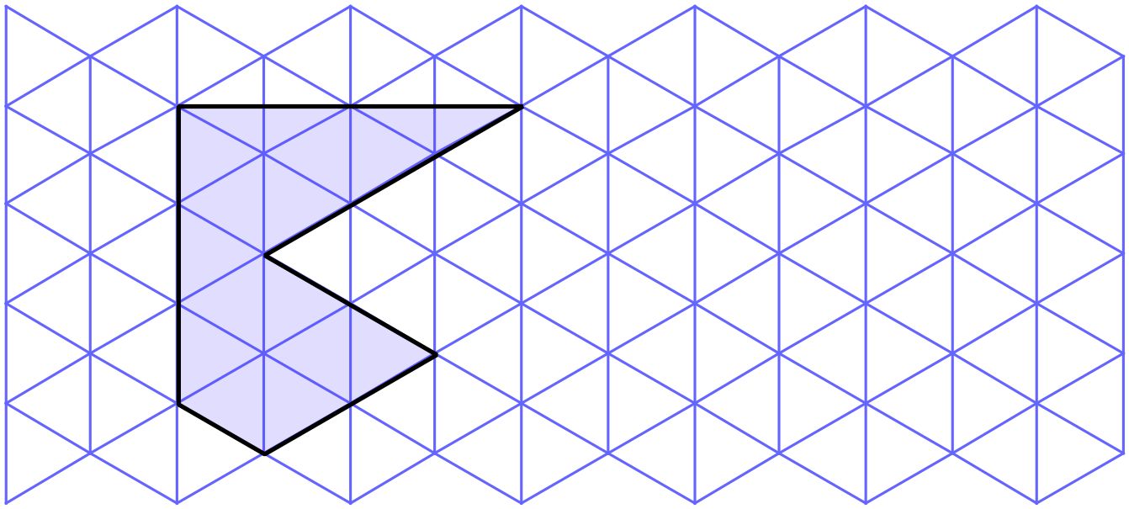

Draw the image of the kite KLMN when it is rotated through 160º about the point O.
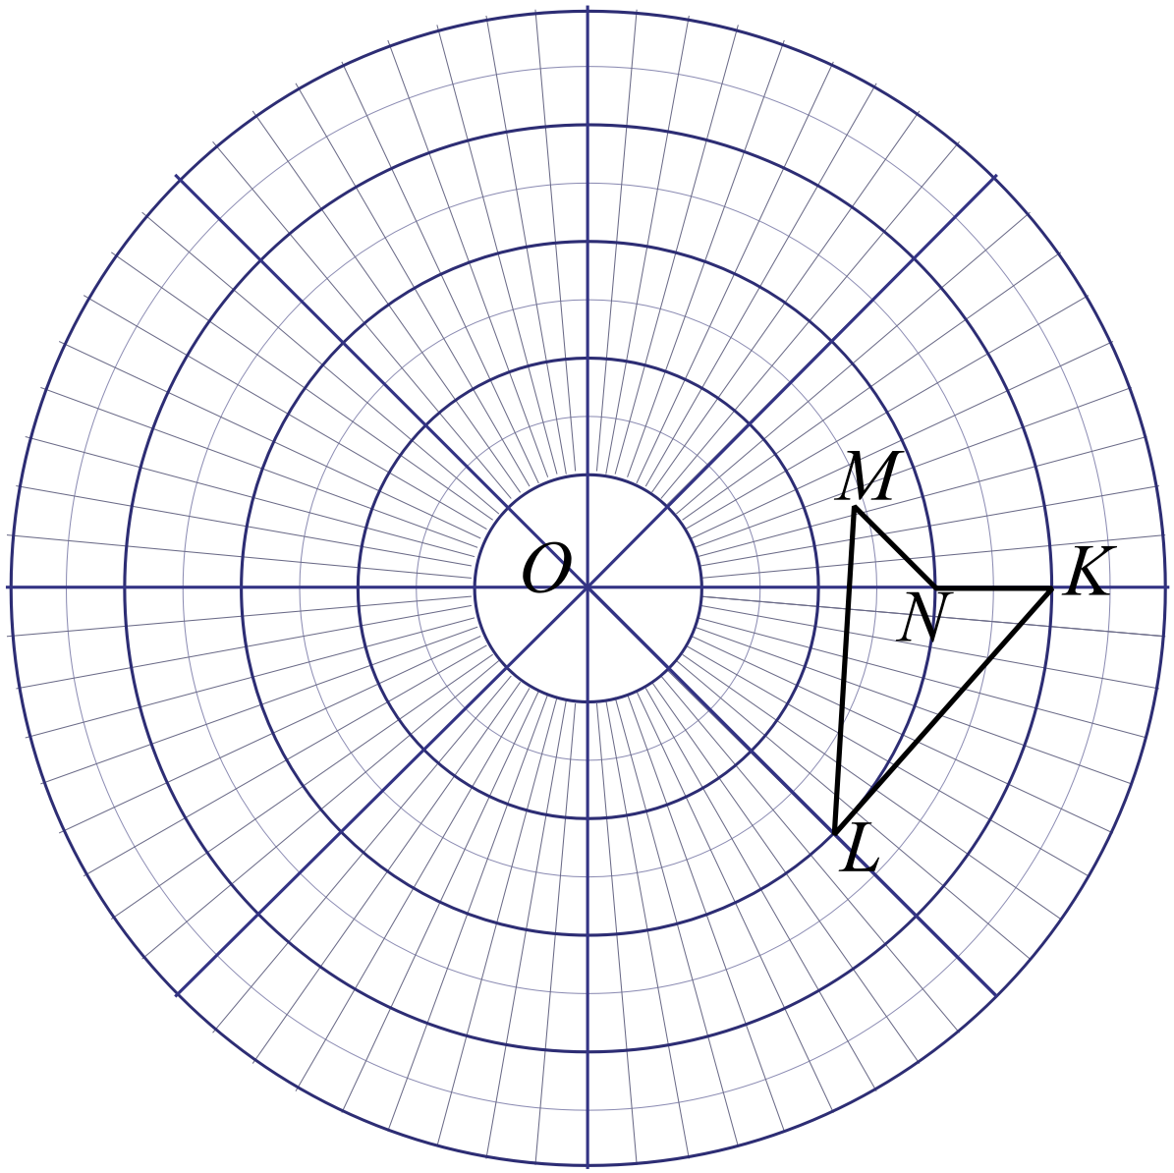

Draw the image of the pentagon CDEFG when it is translated 4 cm in the direction of the arrow.
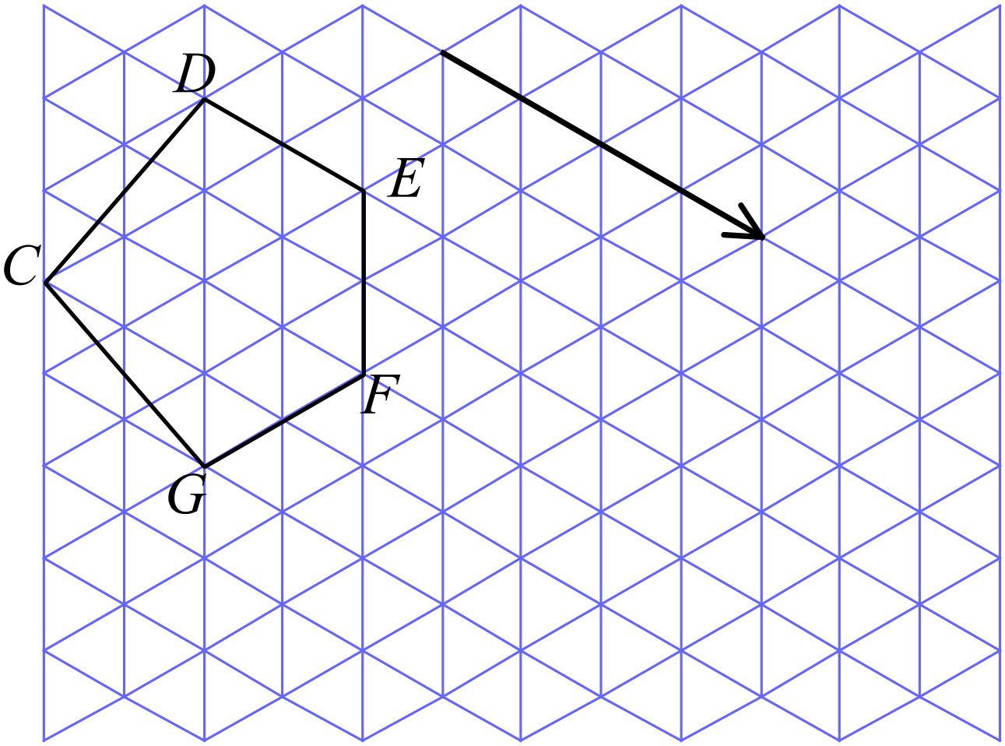

Draw the image of the hexagon when it is reflected in the line AB.
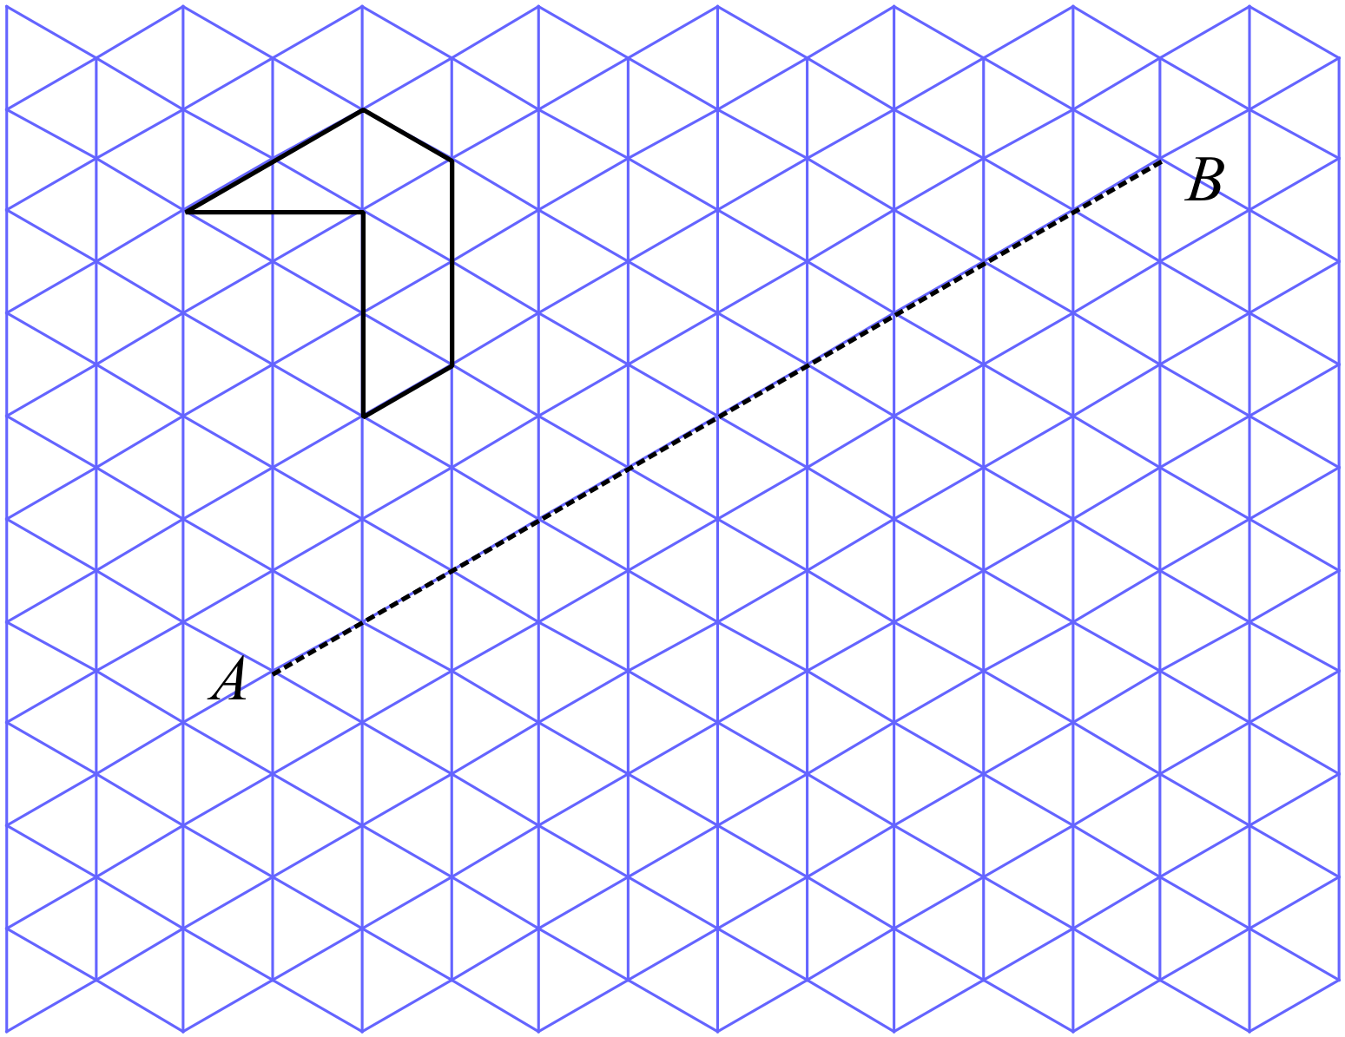

Which two hexagons are congruent? (Write their letters in the space below.)
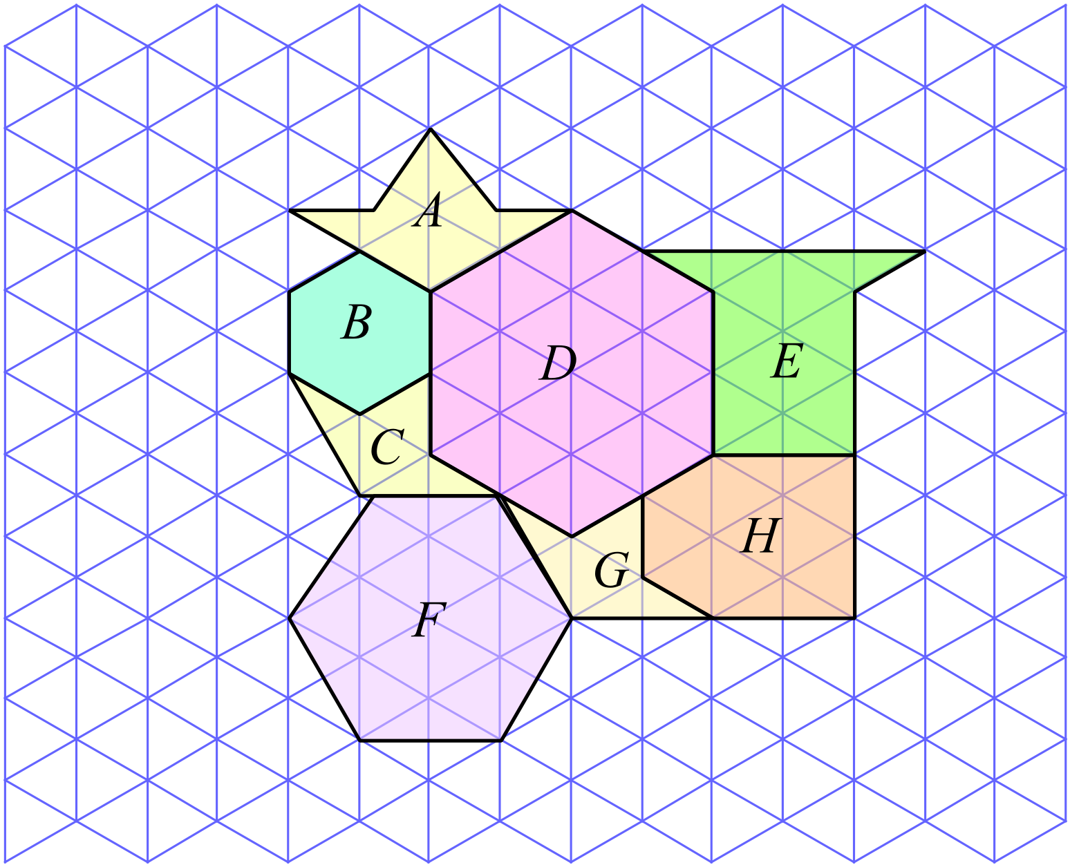

……………………………………………………………………………………………....

……………………………………………………………………………………………….
Explain what information is needed to use the triangle congruence test which is abbreviated as SSS.

……………………………………………………………………………………………....

……………………………………………………………………………………………….
Which of the congruence test (AAS, RHS, SAS or SSS) could be used to show that
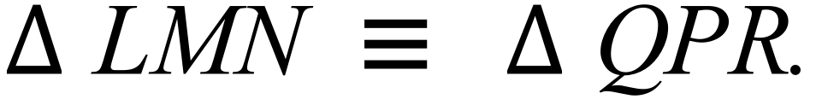
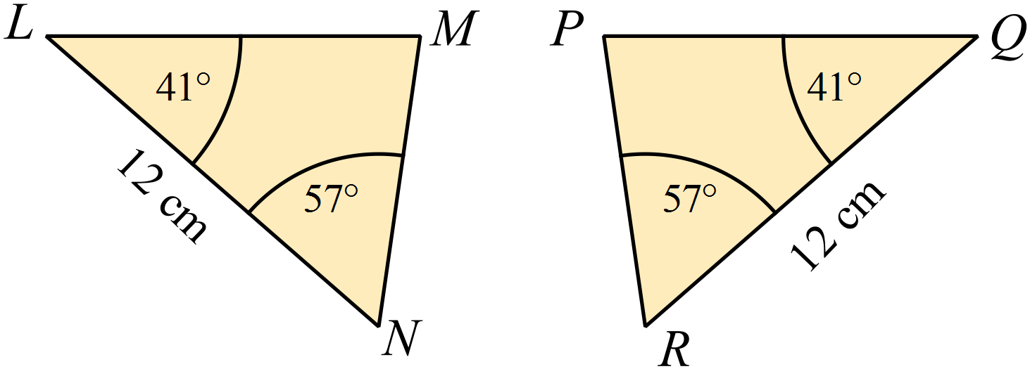

……………………………………………………………………………………………....

……………………………………………………………………………………………….
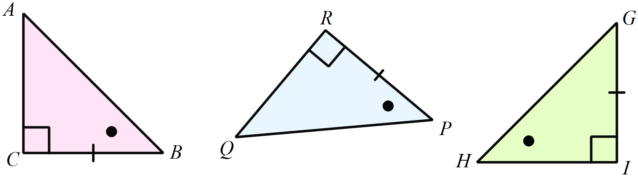Which two triangles below have enough information provided to show they are congruent to one another.

Explain your answer.

……………………………………………………………………………………………....

……………………………………………………………………………………………….
Which of the congruence test (AAS, RHS, SAS or SSS) could be used to prove that
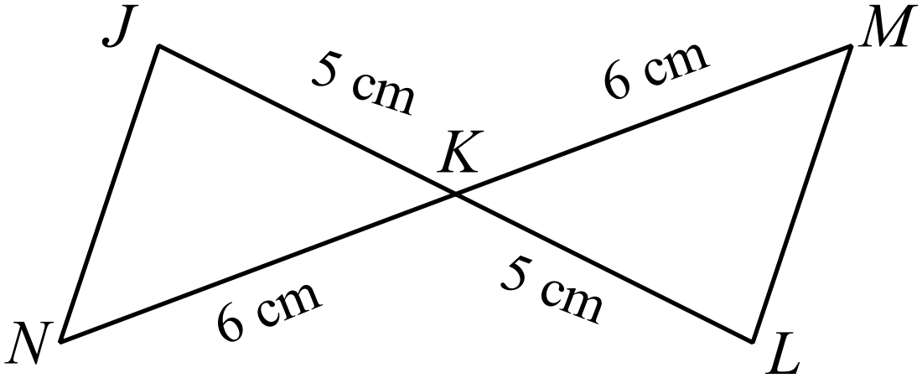

Explain your answer.

……………………………………………………………………………………………....

……………………………………………………………………………………………….
In
What additional piece of information would need to be given, in order to prove that 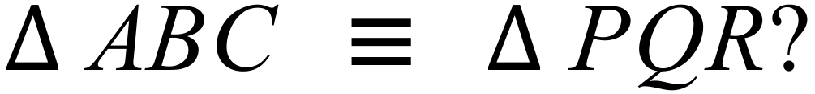
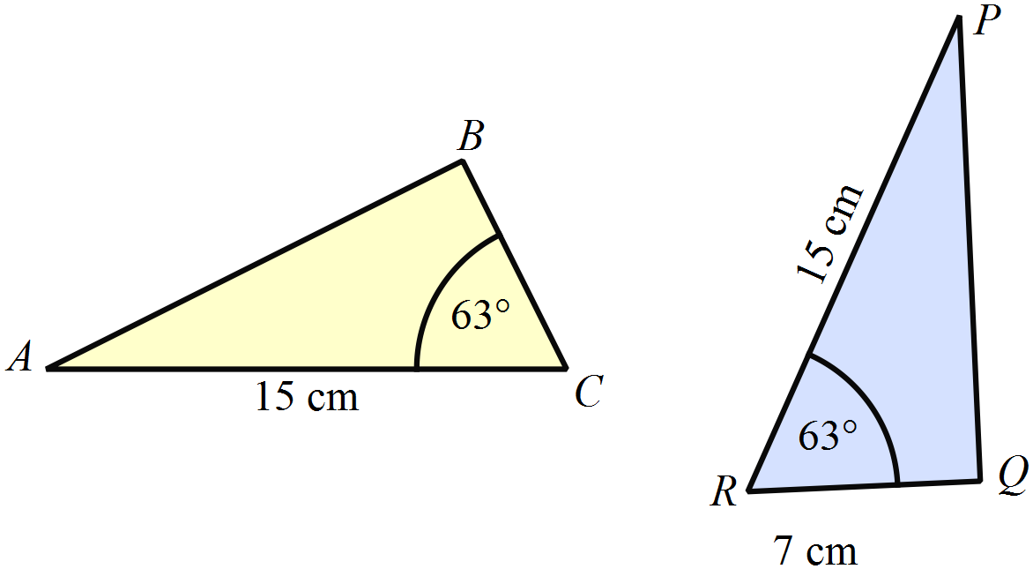Explain your answer.

……………………………………………………………………………………………....

……………………………………………………………………………………………….
In the figure below, AB = EF and .
Give one additional piece of information would allow you to show that and which congruence test would be used?
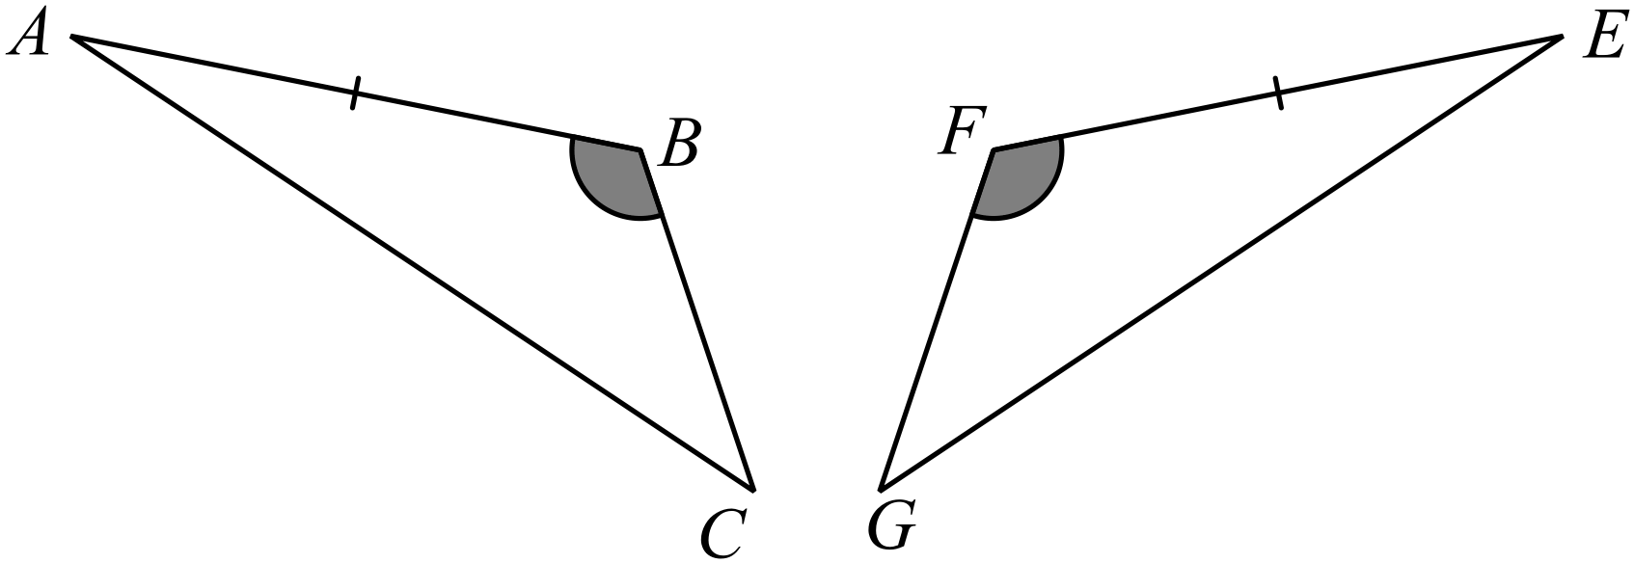

……………………………………………………………………………………………....

……………………………………………………………………………………………….
In the triangles below, MN = QR, NO = PR and MO = PQ.
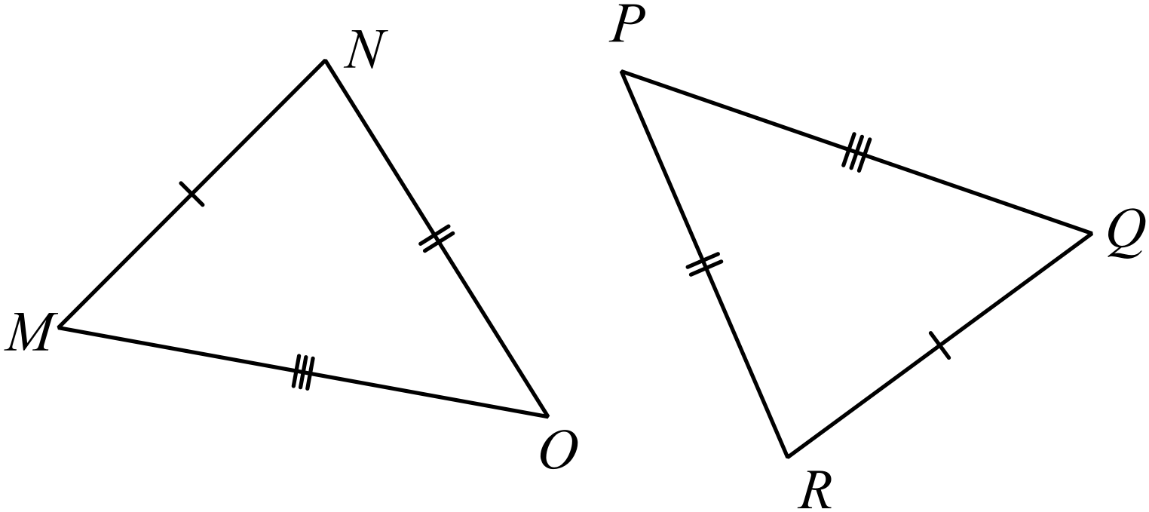

A proof that 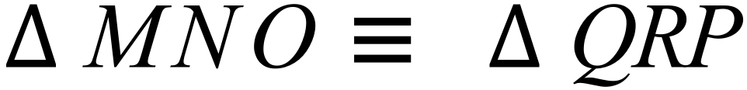 has been started.
Complete the missing sections of the proof.

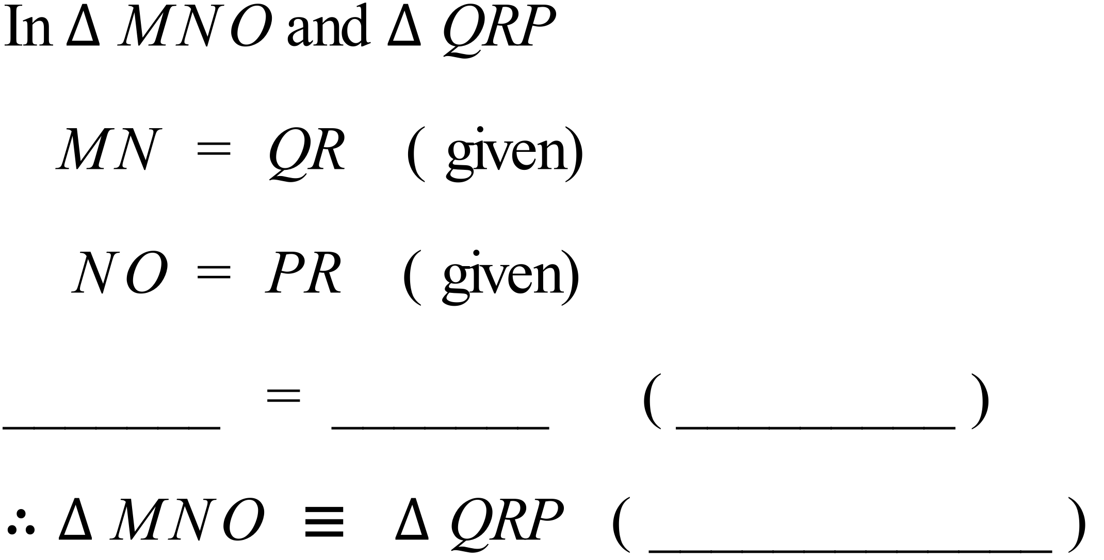

The diagram below is drawn on a grid of congruent hexagons.
It shows a number of triangles, labelled A to F.
Which pair of triangles are congruent and which test could be used to prove this?
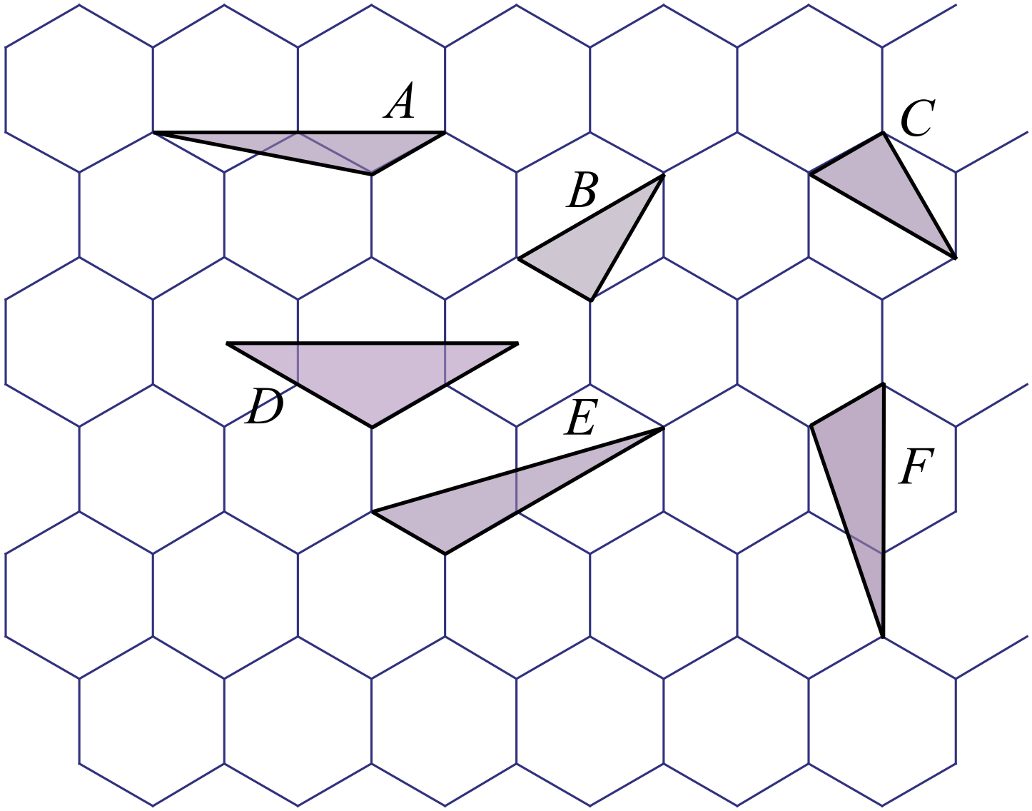

……………………………………………………………………………………………....

……………………………………………………………………………………………….
In the diagram, GF = FI and HF = FJ.
HI and GJ are a straight line segments.
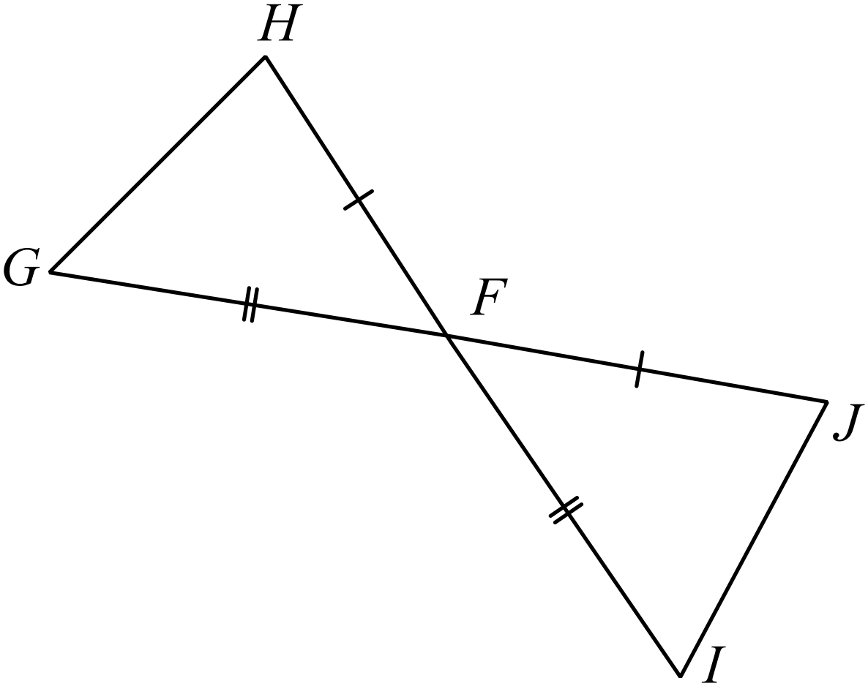Complete the proof below, by filling in the missing information.

Prove that

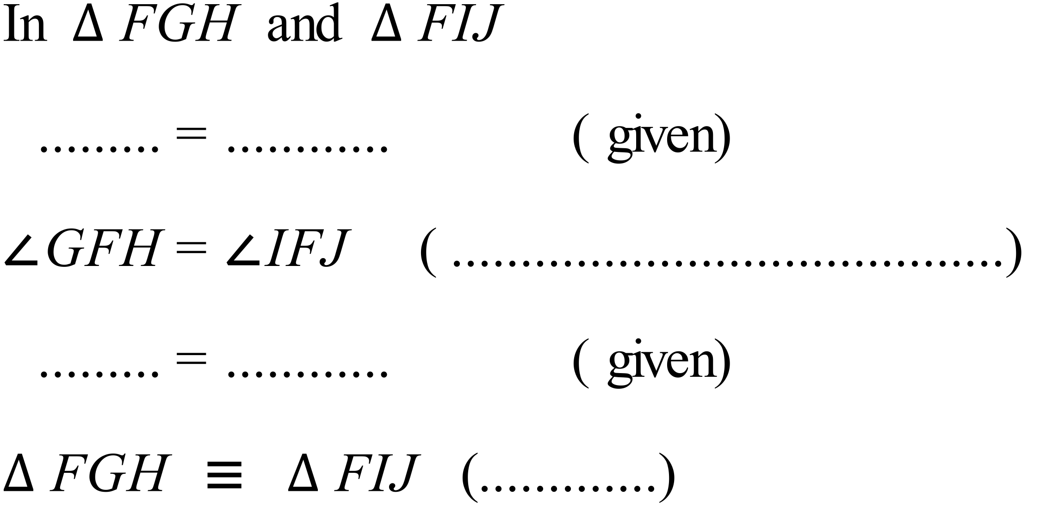

In the diagram and QS is drawn perpendicular to PR.
Complete the proof below, by writing in the reasons for each step.
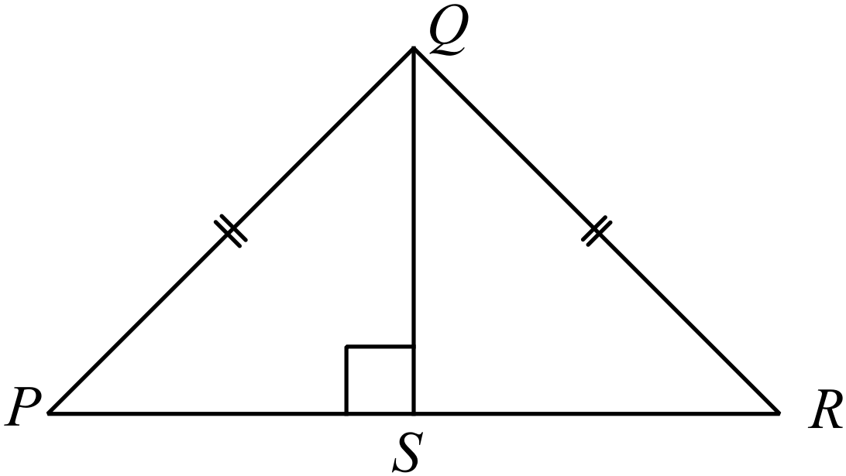
Prove that 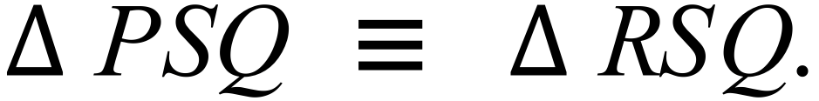
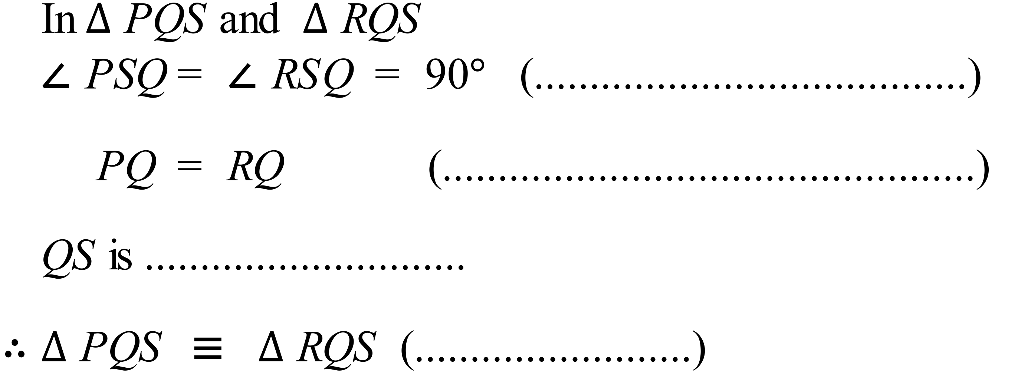

School Name
Mathematics 2017
Year 10 |  | Congruence | Calculator Allowed
 |  | Congruence | Name_________________
Section 2 Multiple Choice Section
Mark all your answers on the accompanying multiple choice answer sheet, not on this test paper. You may do any working out on this test paper. Calculators are allowed for this section.

How many congruent triangles are there in the shape below?
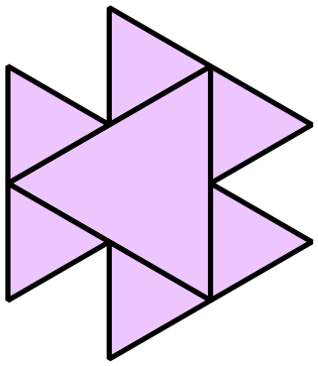

A. 4
B. 5
C. 6
D. 7

Which of the pairs of rectangles listed below are congruent?
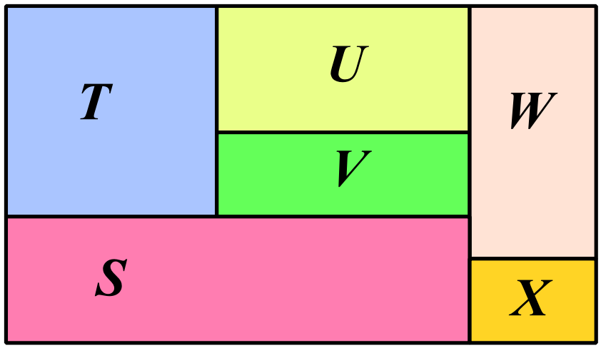

A. S and W B. T and X C. U and V D. U and W
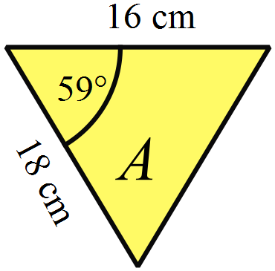Triangle A has the measurements shown at right.
Which of the triangles below is congruent to Triangle A?
The diagrams are not to scale.

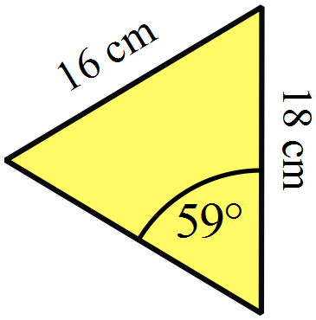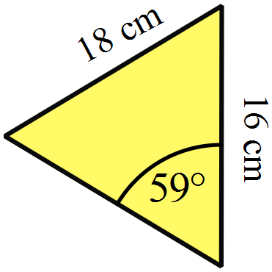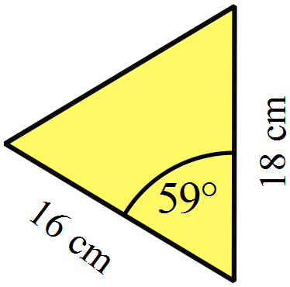 A. B. C. D.
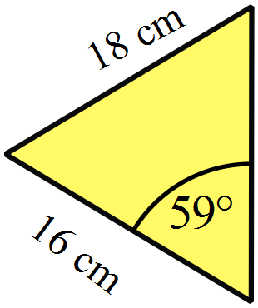

What transformation could have been used to produce the congruent image 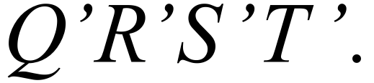
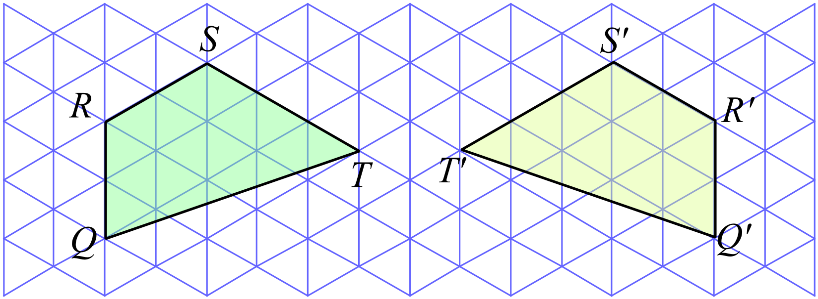

A. Reflection.
B. Rotation through 90º.
C. Rotation through 180º.
D. Translation.

The triangle ABC is rotated through 270º in a clockwise direction about A.
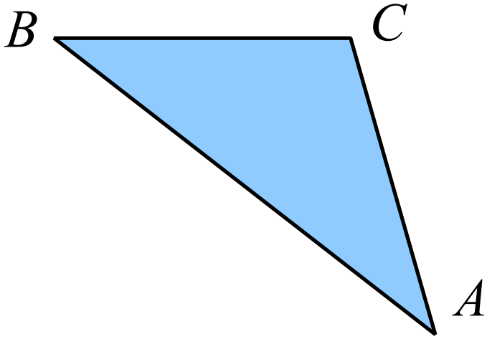

Which diagram shows the correct image?
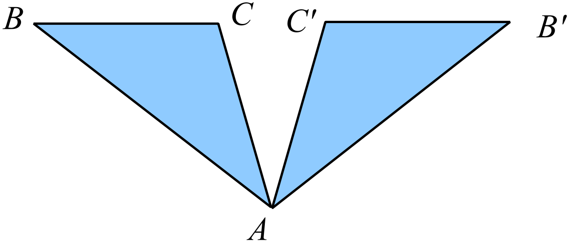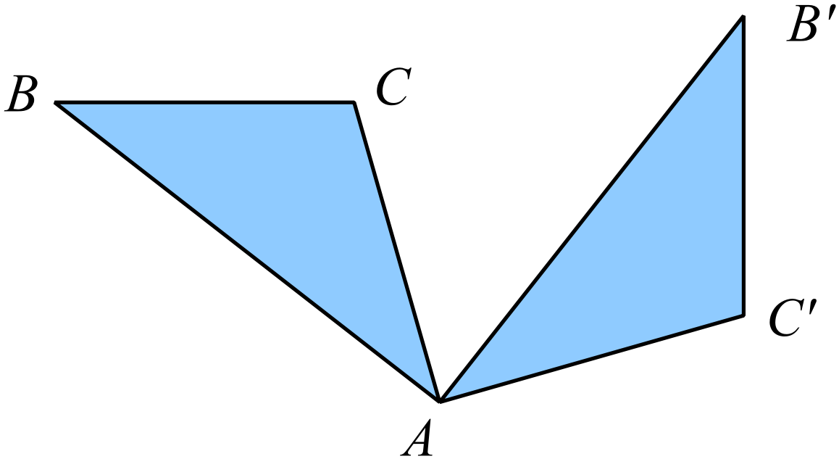 A. B.

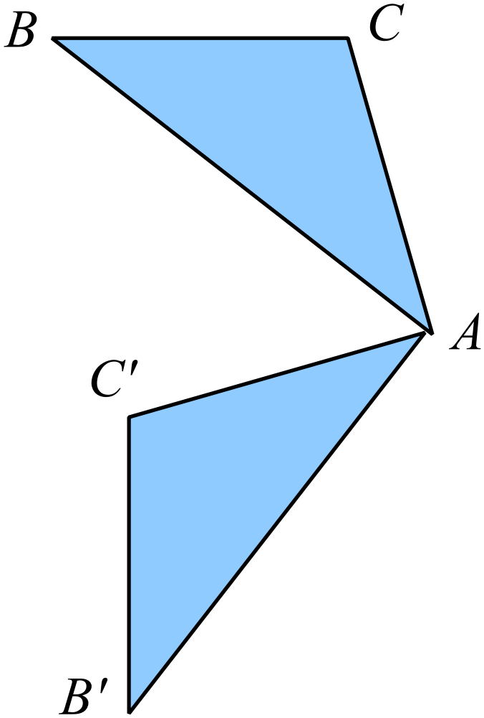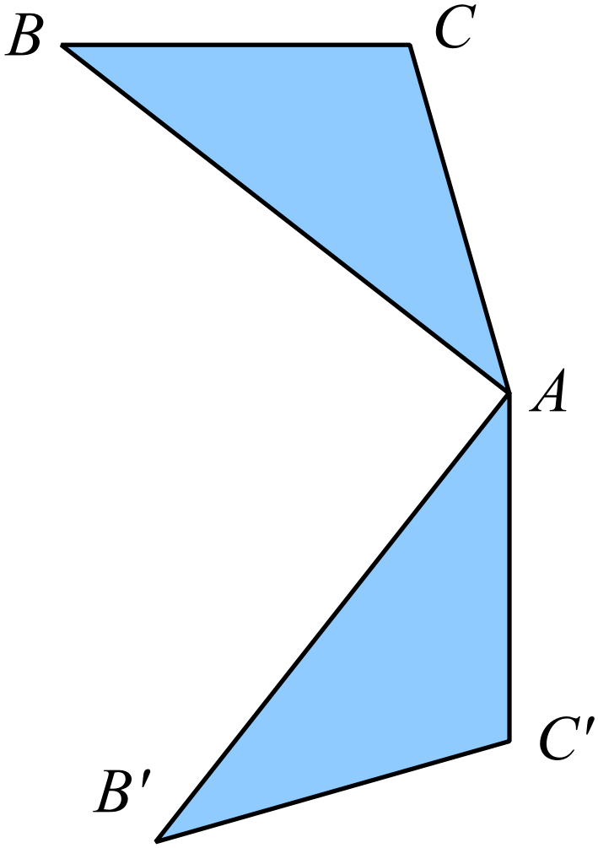 C. D.

Which triangle is congruent to 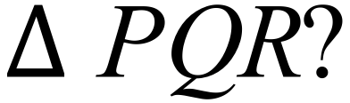
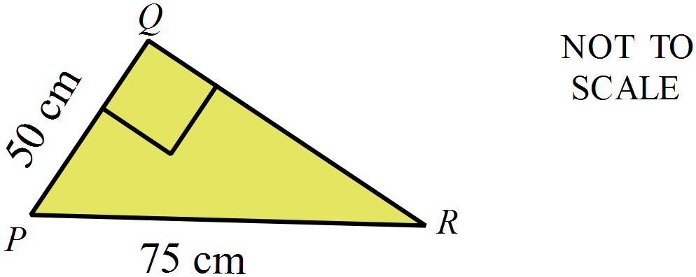

- 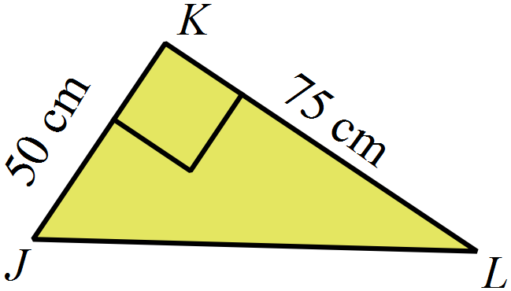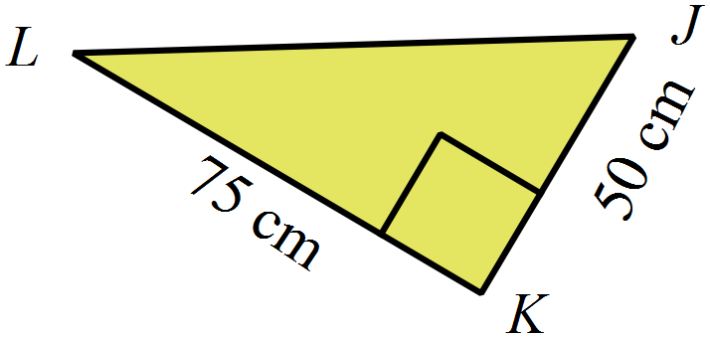 B.

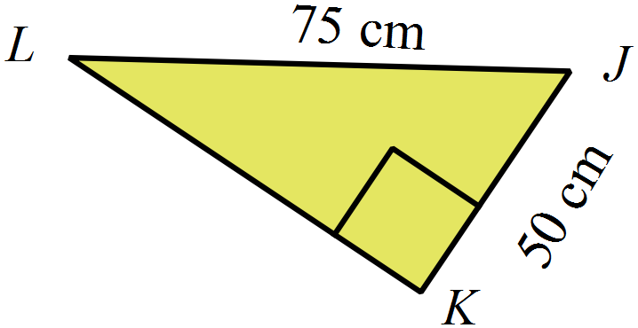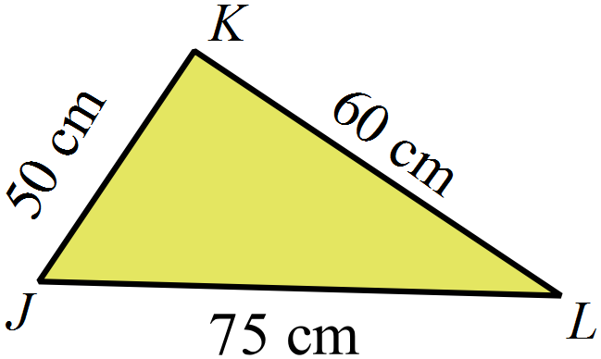
C. D.

Figure ABCD is moved to an image 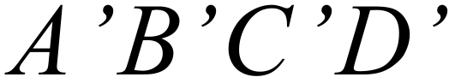 by a single transformation.
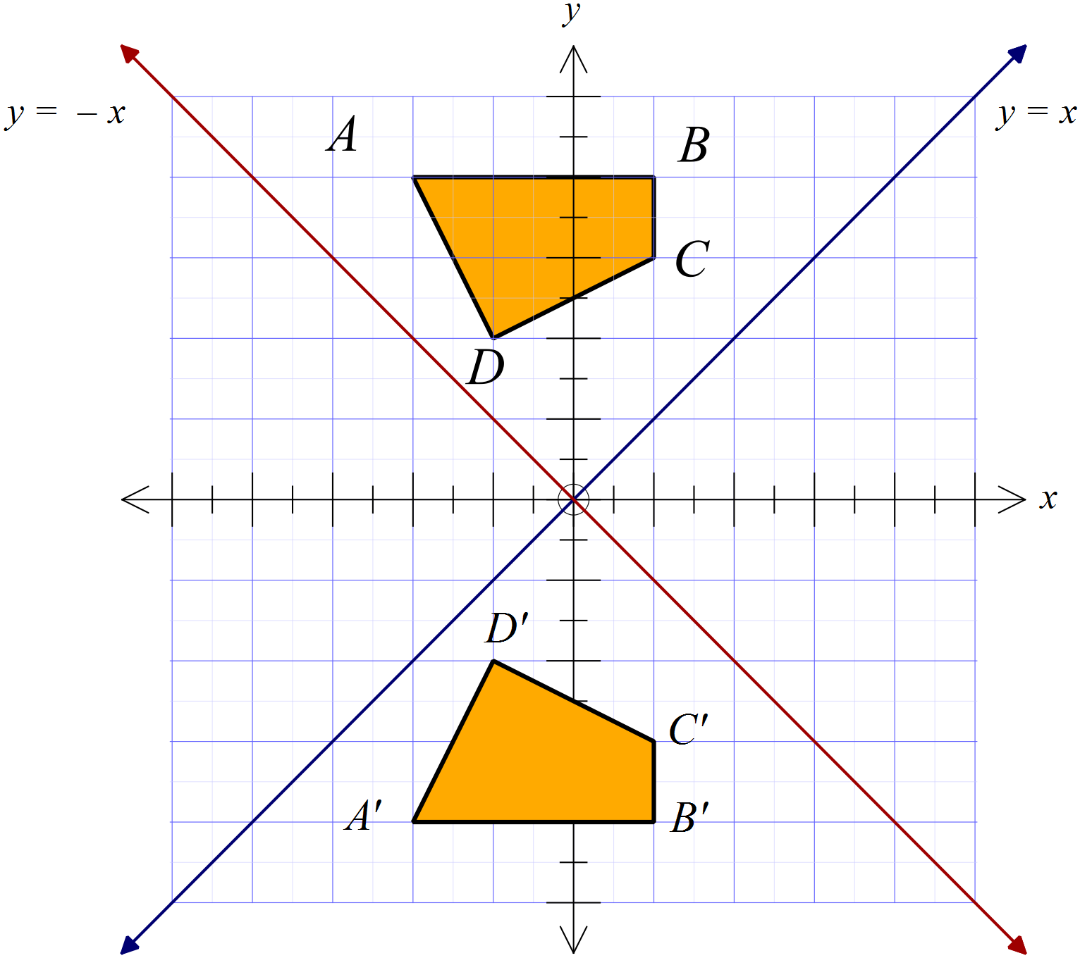What was the transformation?

A. A clockwise rotation of 180º about the origin.
B. A reflection in the x axis.
C. A reflection in the line y = x.
D. A reflection in the line y = -x

Which shape is congruent to shape M?
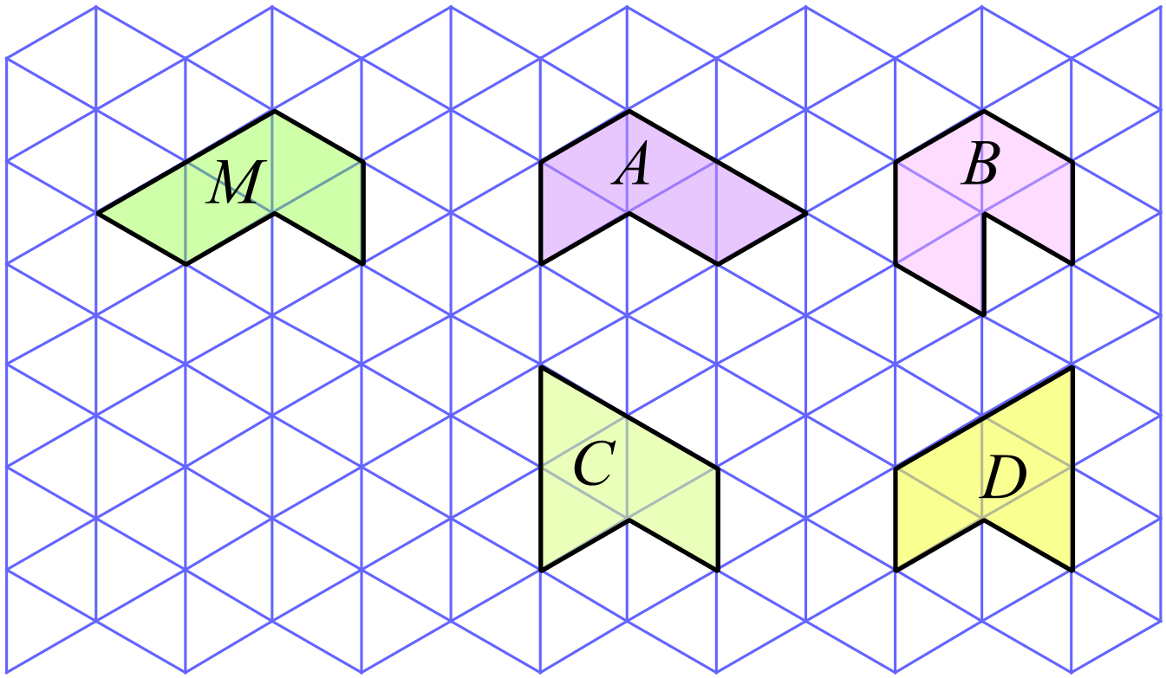

A. Shape A B. Shape B C. Shape C D. Shape D

KLNM is a rectangle and LNO is a right isosceles triangle.
The trapezium KLOM is rotated through 90º in an anticlockwise direction about O.
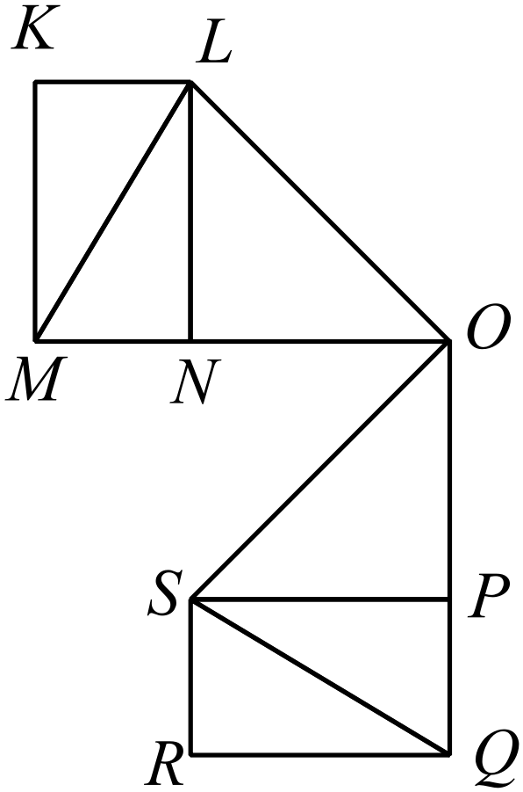
Which of the following is a pair of congruent triangles?

A. 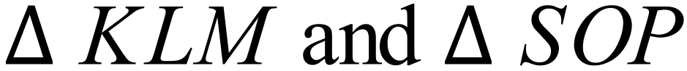
B. 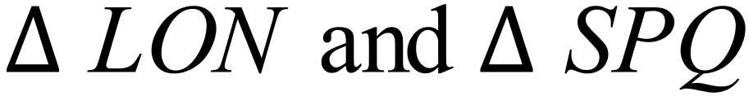
C. 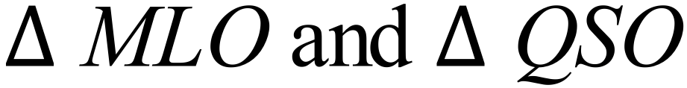
D. 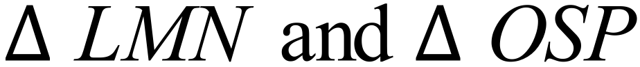
Which two congruence tests could be used to prove that ?
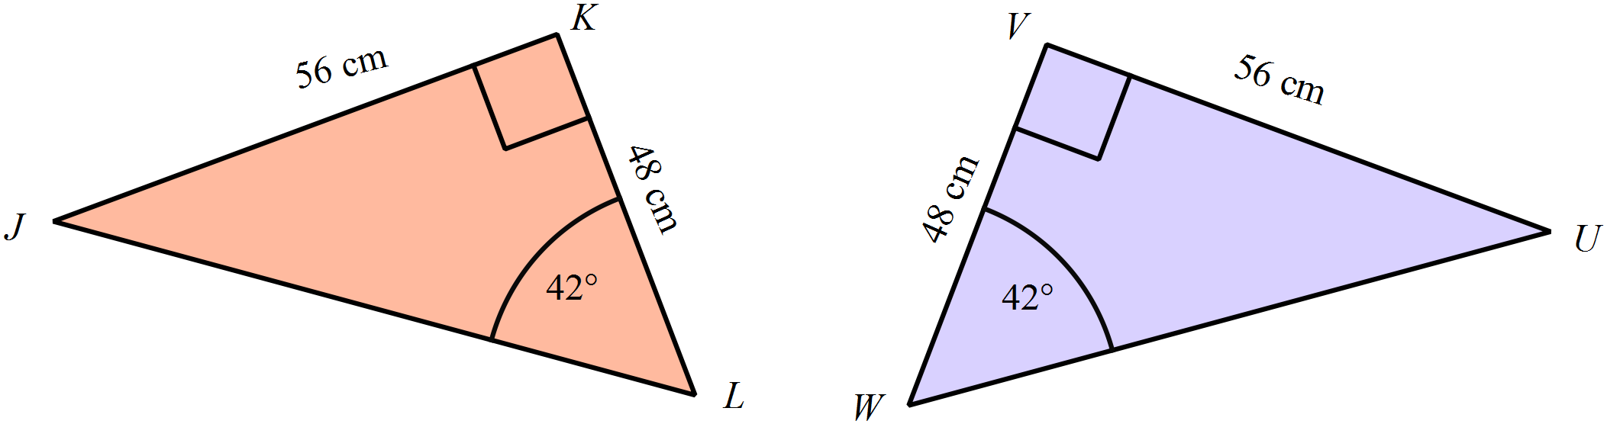

A. AAS or RHS B. AAS or SAS C. SAS or RHS D. SAS or SSS
Which triangles are congruent?
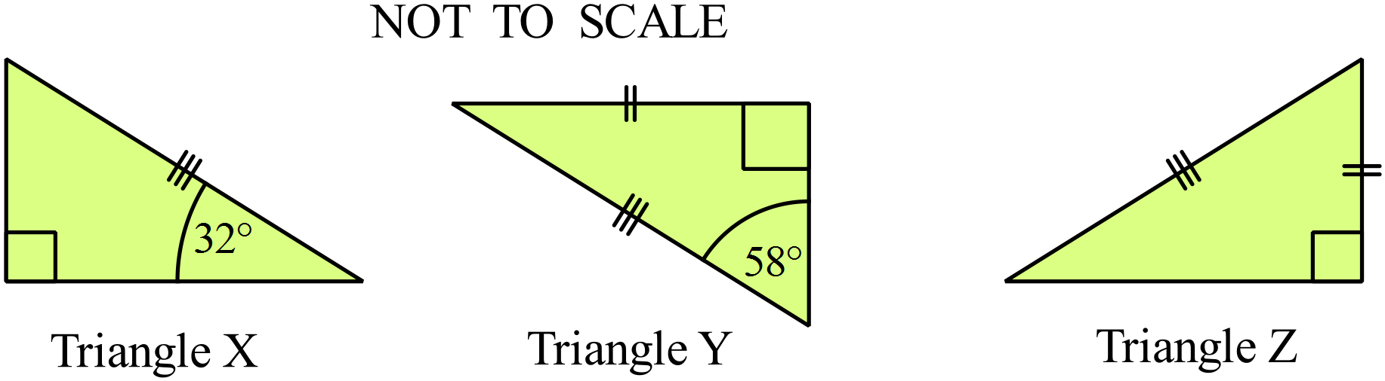

A. All three triangles.
B. Triangles X and Y.
C. Triangles X and Z.
D. Triangles Y and Z.
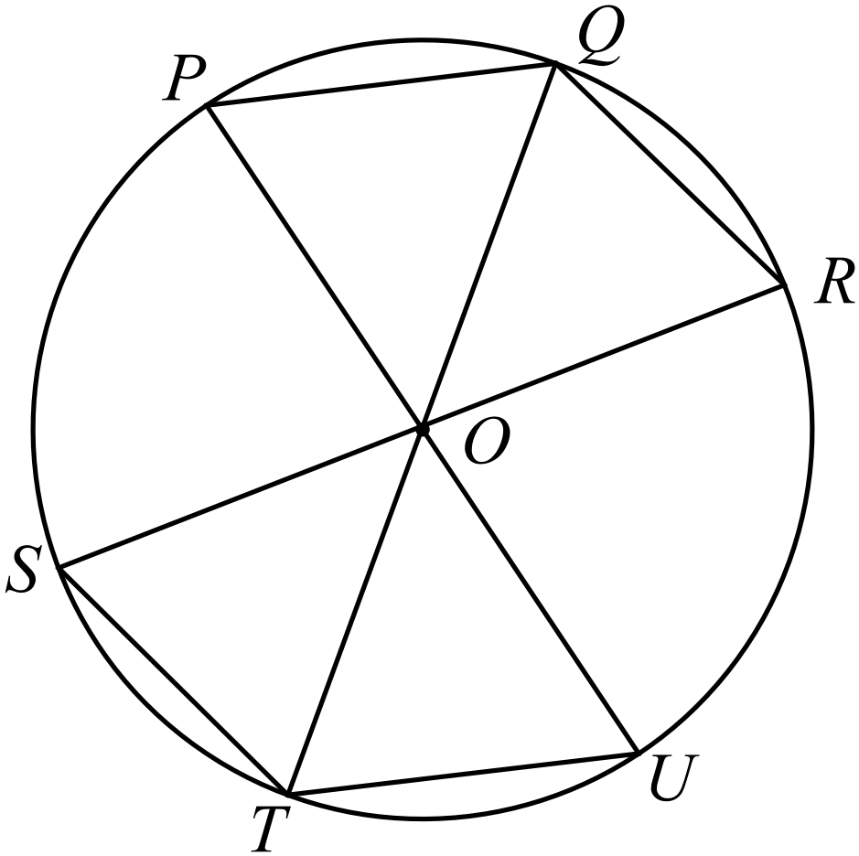The circle shown has centre O.
PU, QT and RS are diameters of the circle.
Which pair of triangles are congruent?

A. 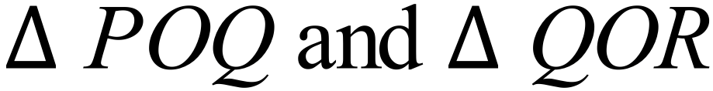
B. 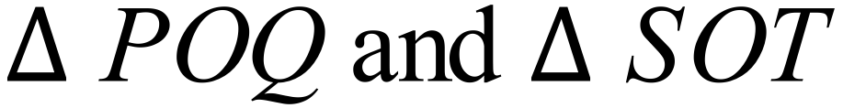
C. 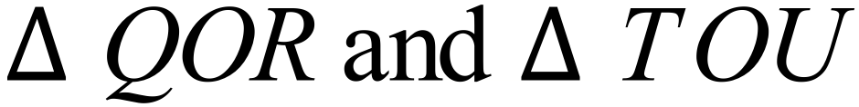
D. 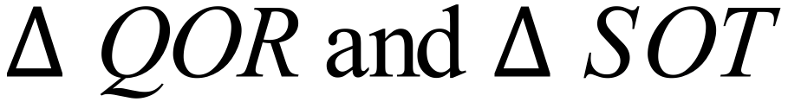
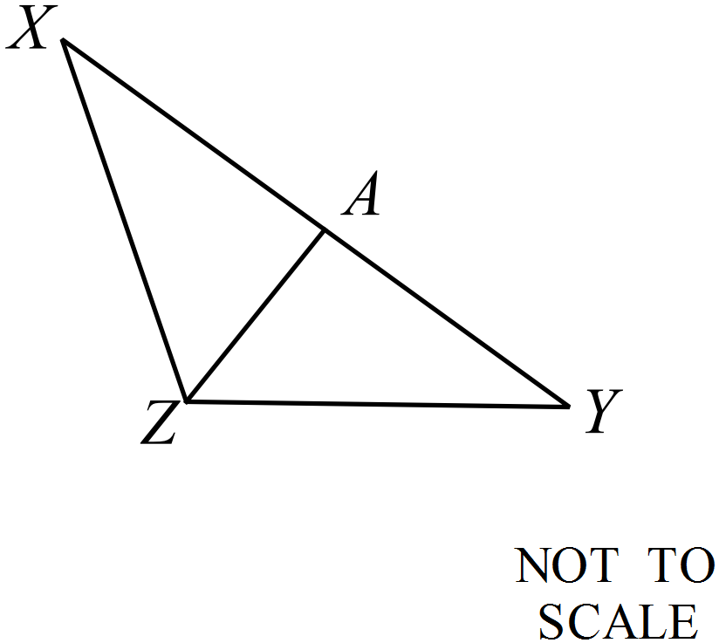
Without using any further properties of triangles, which of the congruence tests could be used to show 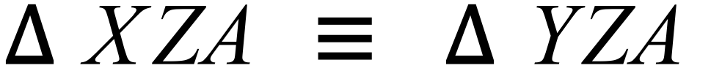 ?

A. AAS
B. RHS
C. SAS
D. SSS
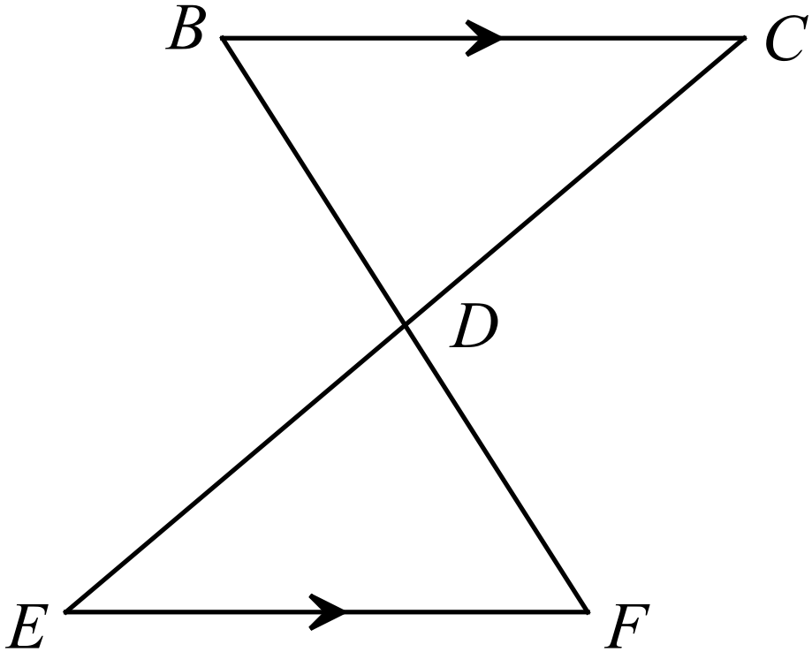In the figure below, BC || EF.
Which single additional piece of information would allow you to show that

A. 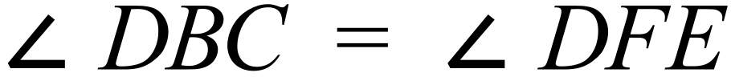
B. 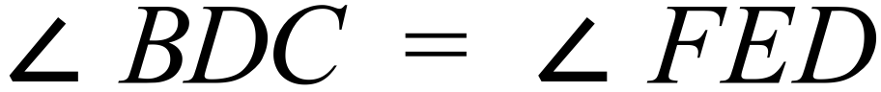
C. 
D. 
PQRS is a parallelogram and T and U are the points on PQ and SR such that PT = SU.
One line has been left out of the proof below.
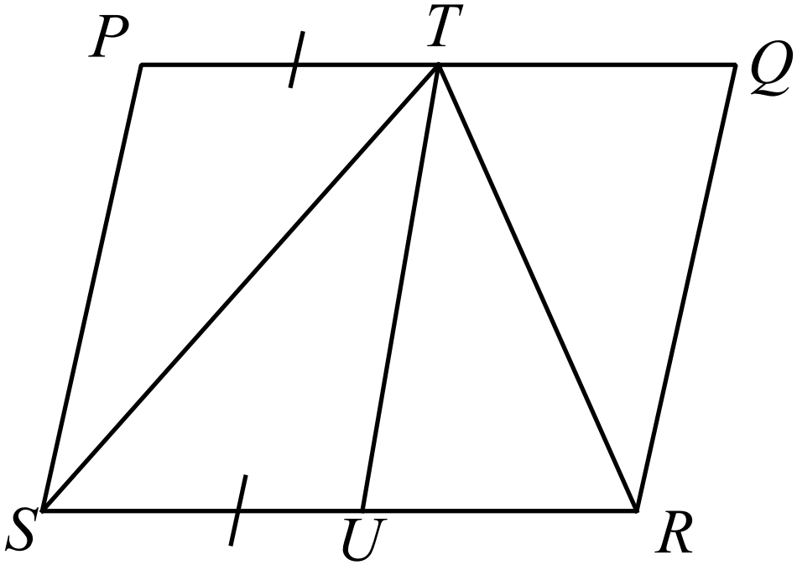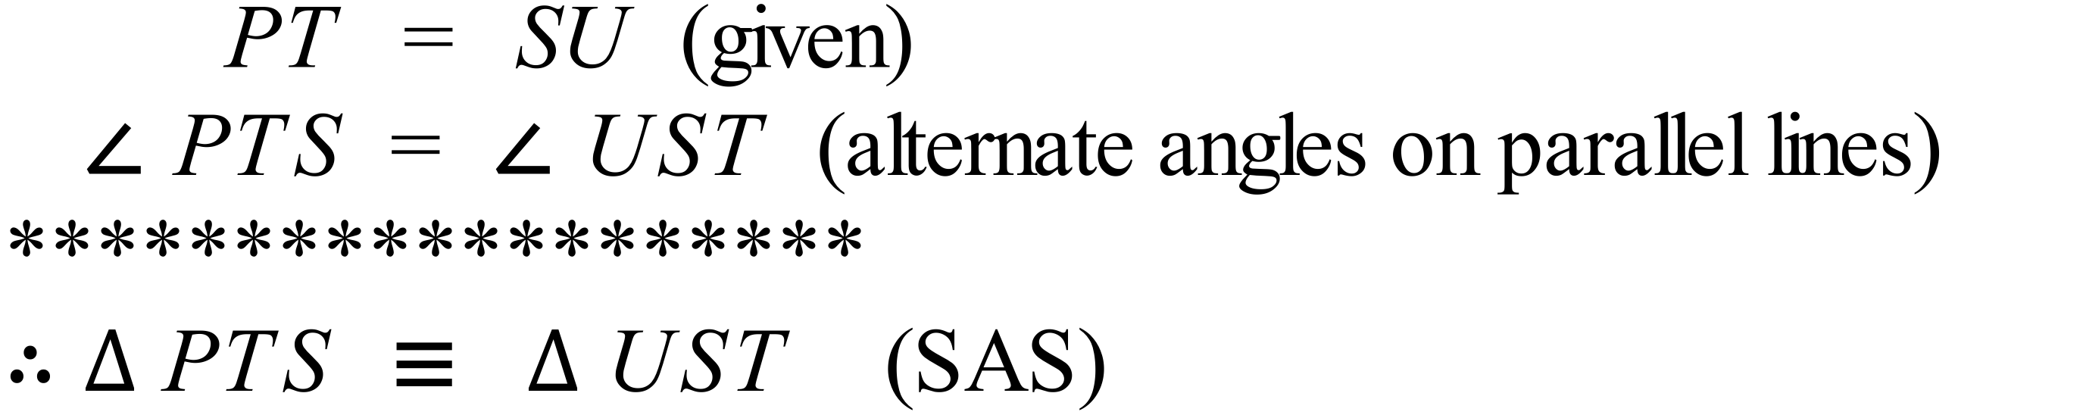
Which statement would complete the proof ?
A.
B. 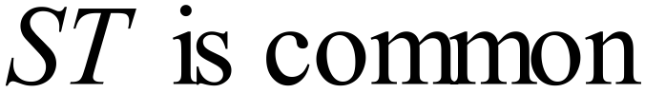
C.
D.

School Name
Mathematics 2017
Year 10 | Congruence | Calculator Allowed
Year 10 | Congruence | Name___________________
Section 3 Longer Answer Section
Write all working and answers in the spaces provided on this test paper.

 |  | Marks
1. | (a) Translate the polygon DEFGH in the distance and direction of the ray OP.  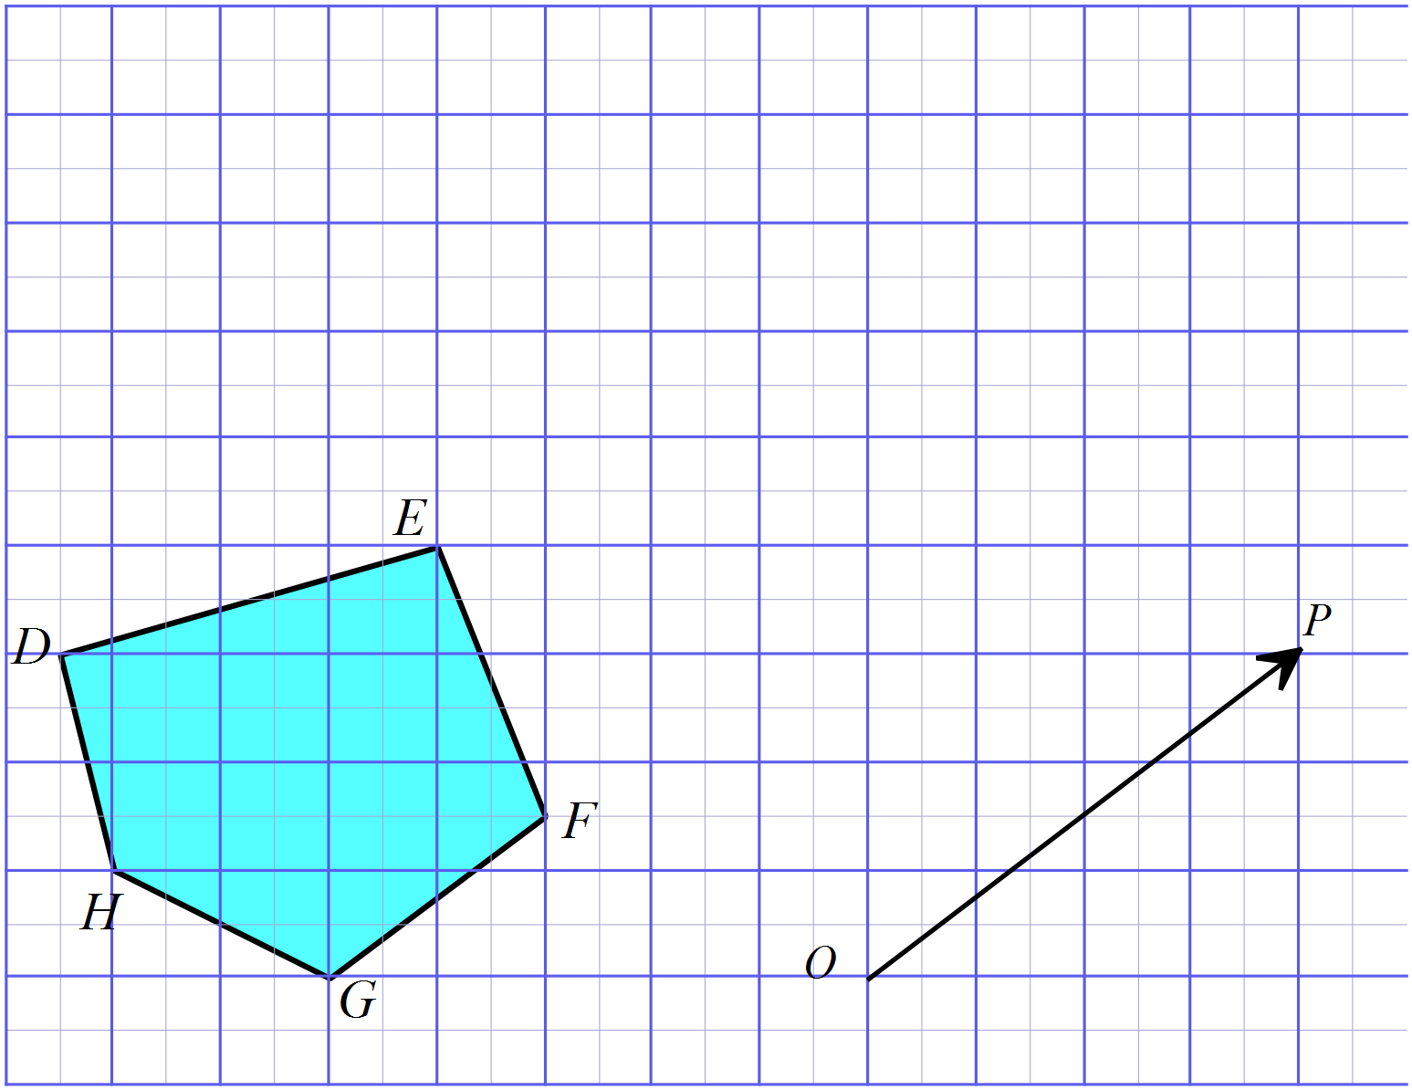 | 2
 | (b) Label the image after the translation as D’E’F’G’H’. | 1
 | (c) What two properties are shared by the sides EF and E’F’ ?  ……………………………………………………………………………………………....  ………………………………………………………………………………………………. | 2
2. | 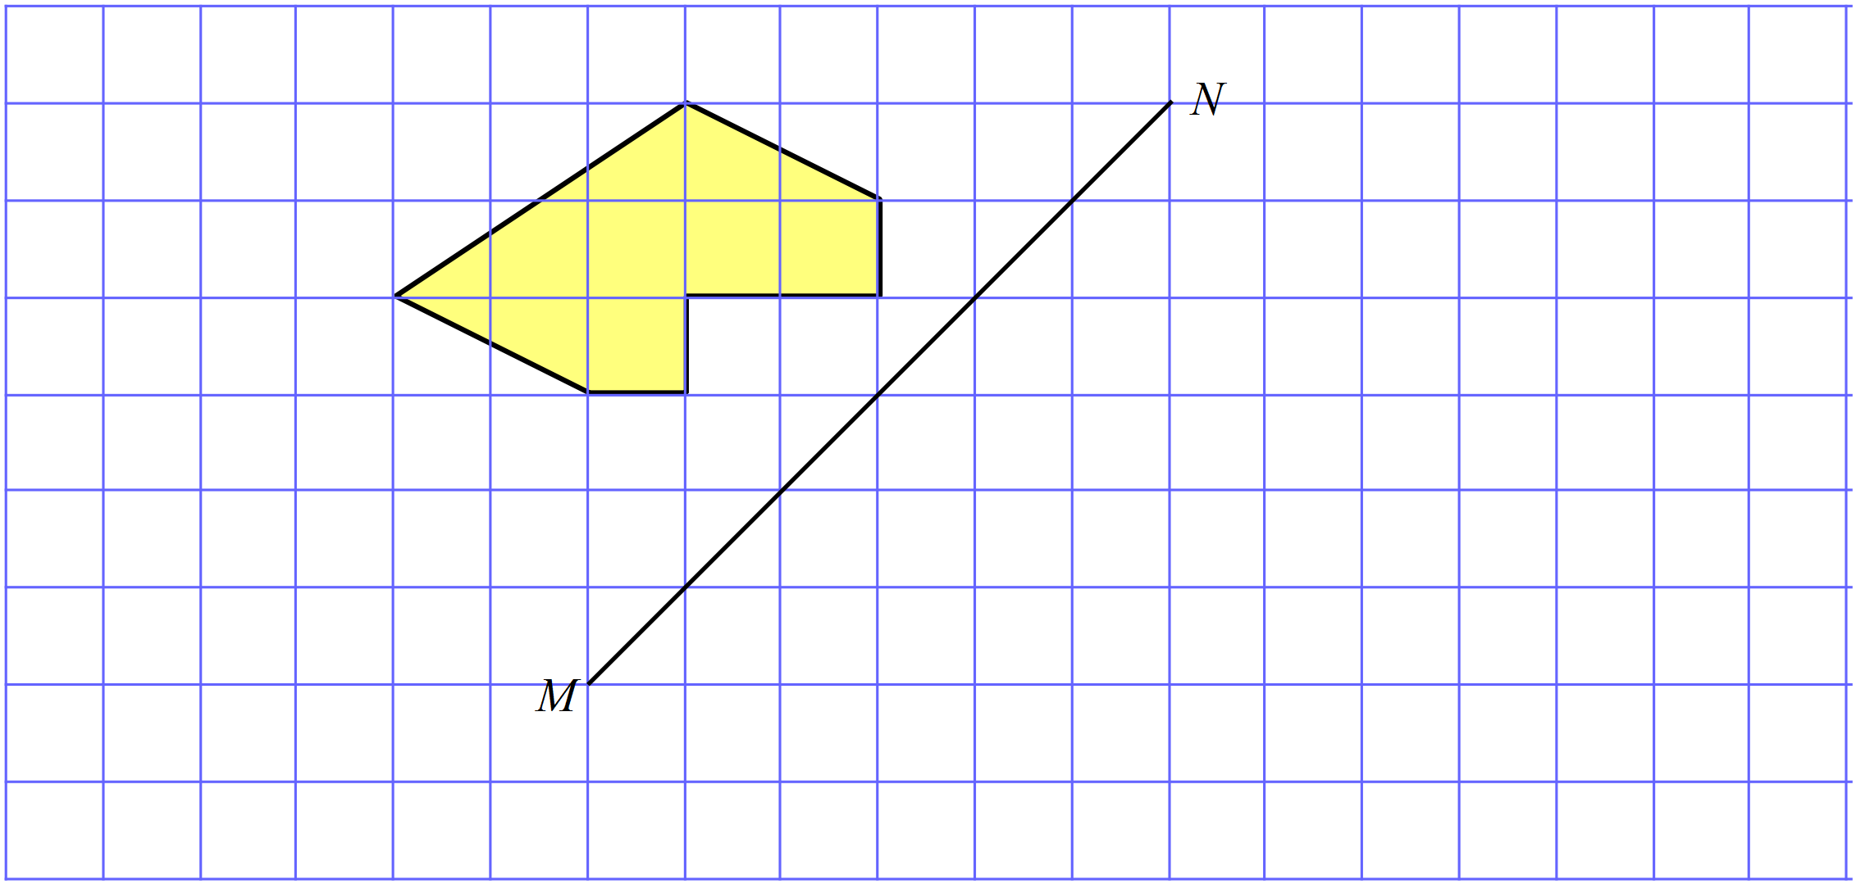Draw the image of the shape below when it is reflected in the line MN. | 2
 | (b) What could be said about the perimeter of the shape and its image?  ……………………………………………………………………………………………....  ………………………………………………………………………………………………. | 1
 | (c) What could be said about the area of the shape and its image?  ……………………………………………………………………………………………....  ………………………………………………………………………………………………. | 1
3. | (a) A triangle has three sides whose lengths are given below.  Use instruments to accurately draw the triangle. (Do not erase your construction lines.) | 2
 | (b) A right triangle has a base which measures 10 cm, and a hypotenuse which is 14 cm in length.  Use instruments to accurately draw the triangle. | 2
4. | 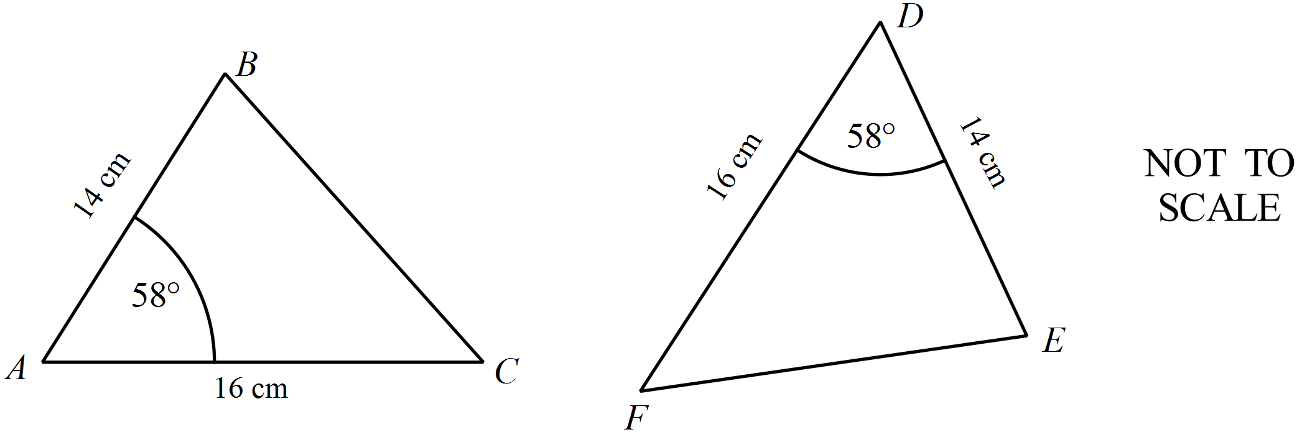(a) Prove that  ………………………………………………………………………………………………………………………………………………….  …………………………………………………………………………………………………………………………………………………  …………………………………………………………………………………………………………………………………………………  ………………………………………………………………………………………………………………………………………………….  ………………………………………………………………………………………………………………………………………………… | 3
 | (b) In the diagram below, ST = VW, and U is the midpoint of TV.  Prove that  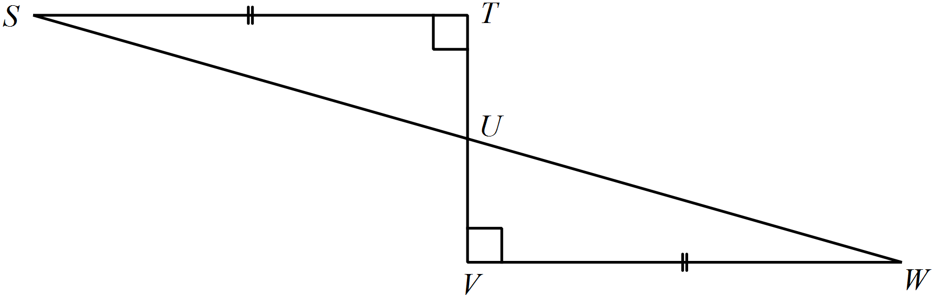  …………………………………………………………………………………………………………………………………………………  …………………………………………………………………………………………………………………………………………………  …………………………………………………………………………………………………………………………………………………  …………………………………………………………………………………………………………………………………………………  …………………………………………………………………………………………………………………………………………………  ………………………………………………………………………………………………………………………………………………….  ………………………………………………………………………………………………………………………………………………… | 3
 | (c) In the diagram below, LM || PO, MN || PQ and LQ = NO.  Prove that  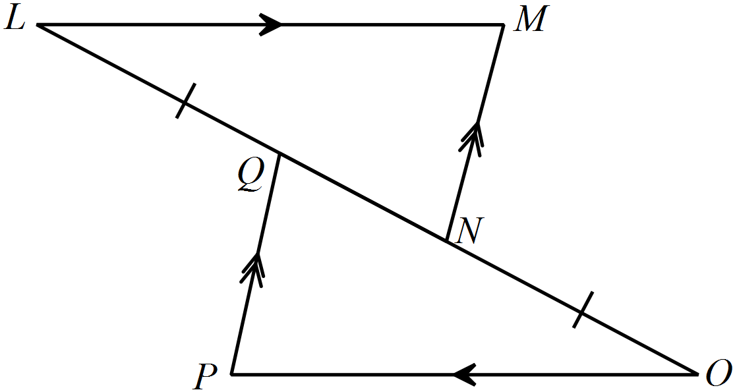  …………………………………………………………………………………………………………………………………………………  …………………………………………………………………………………………………………………………………………………  …………………………………………………………………………………………………………………………………………………  ………………………………………………………………………………………………………………………………………………….  …………………………………………………………………………………………………………………………………………………  …………………………………………………………………………………………………………………………………………………  ………………………………………………………………………………………………………………………………………………….  ………………………………………………………………………………………………………………………………………………… | 3

School Name
Mathematics 2017
Multiple Choice Answer Sheet
Congruence
Name _____________________________________________
Completely fill the response oval representing the most correct answer.

1. A B C D
2. A B C D
3. A B C D
4. A B C D
5. A B C D
6. A B C D
7. A B C D
8. A B C D
9. A B C D
10. A B C D
11. A B C D
12. A B C D
13. A B C D
14. A B C D
15. A B C D

School Name
Mathematics Test 2017
Year 10 | Congruence | Non Calculator Section
ANSWERS

Question | Working
 | 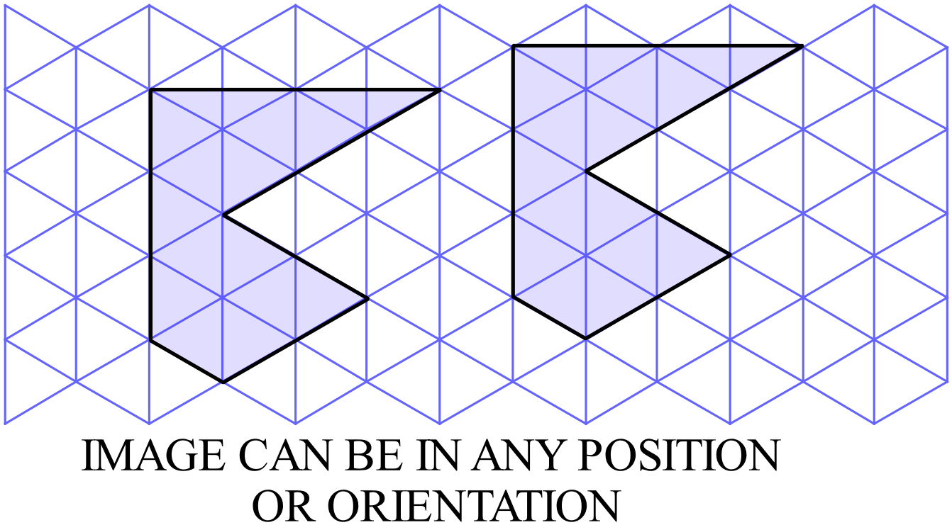
 | 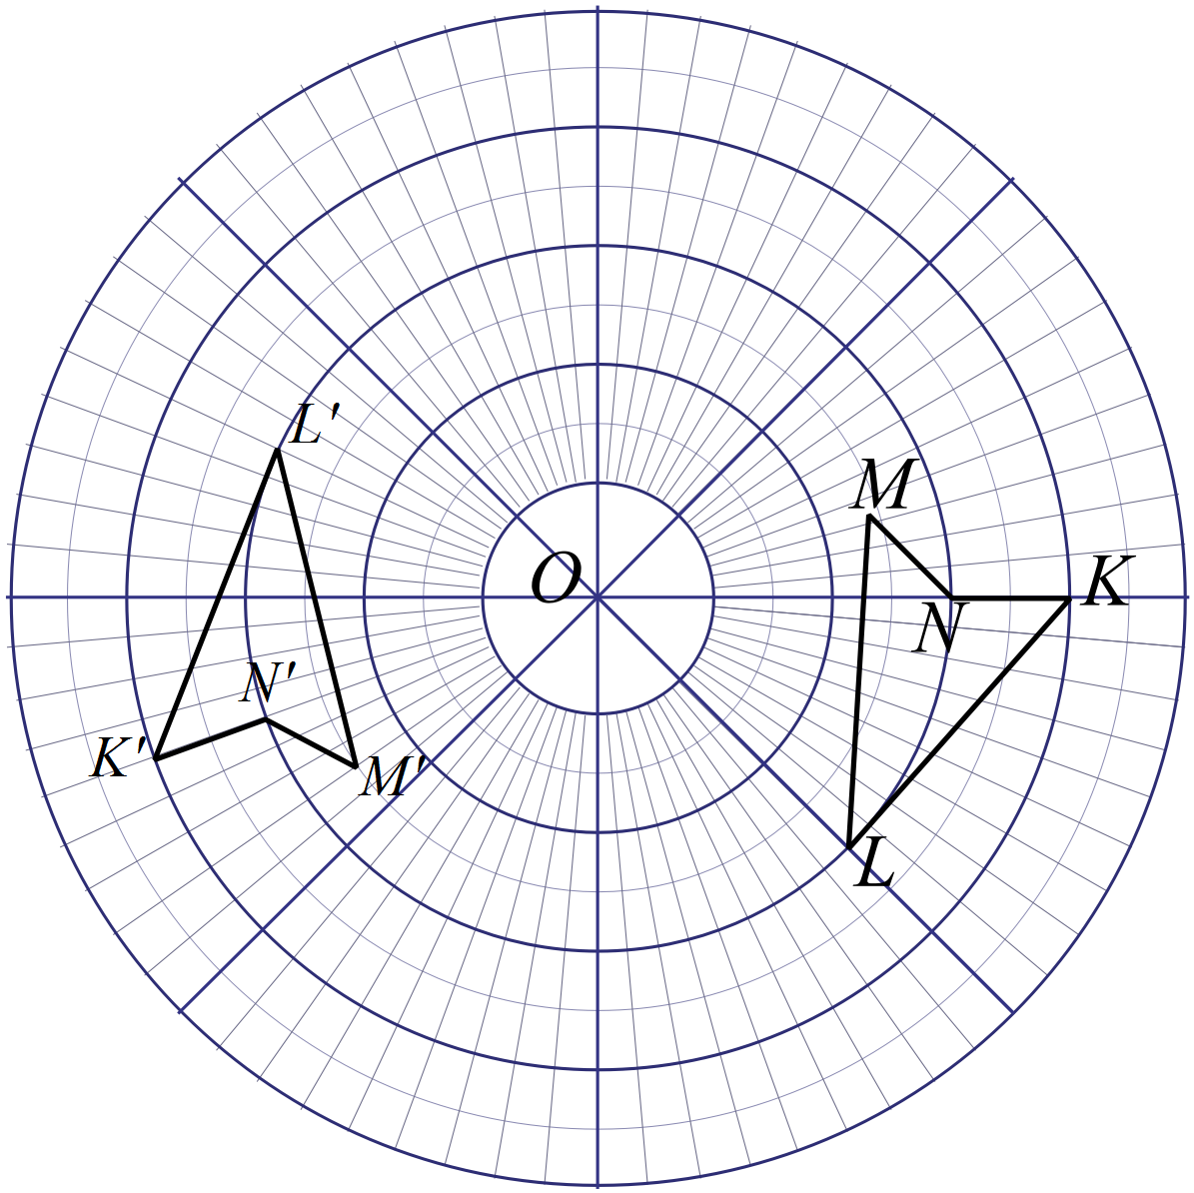
 | 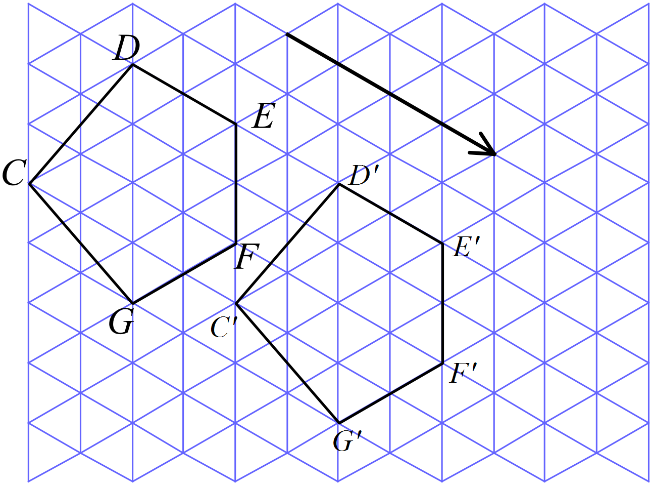
 | 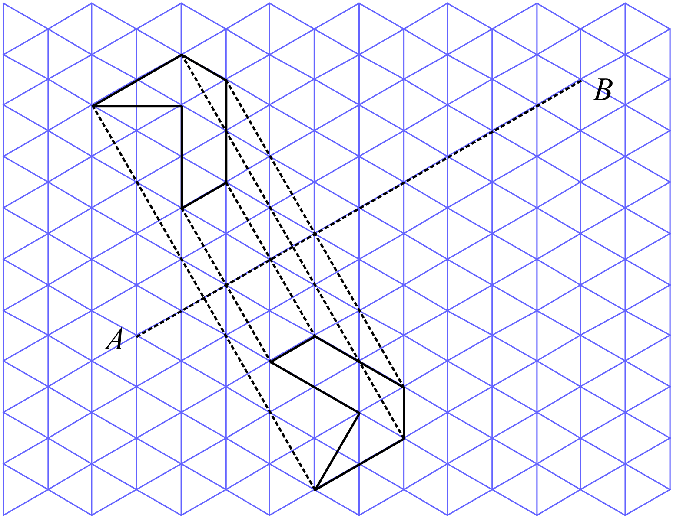
 | C and G are the only congruent hexagons.
 | The three sides of one triangle are equal in length to the corresponding three sides of the second triangle.
 | The Test AAS could be used as there are a pair of angles which are equal and the side between them in each triangle is equal.
 | Triangles ABC and PQR are congruent, as the side which is equal is in the same corresponding position in both triangles relative to the equal angles so can use AAS.
 | The test SAS could be used, as there are a pair of corresponding sides equal, (given) and the angle between them is equal (vertically opposite angles)
 | We have one pair of equal angles and one pair of equal sides. In triangle PQR, the side RQ is given as 7cm giving SAS, so we need side BC = 7cm.
We have a pair of equal angles and a pair of equal sides which form one arm of the angle.
If we were given that BC = FG we could use SAS.
If we were given that 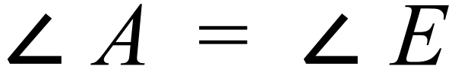 we could use AAS.
If we were given that  we could use AAS.

 | 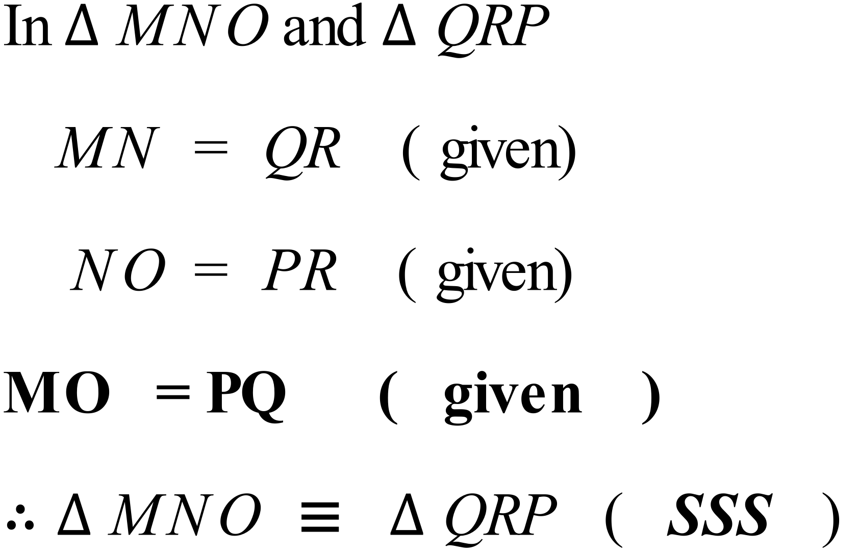
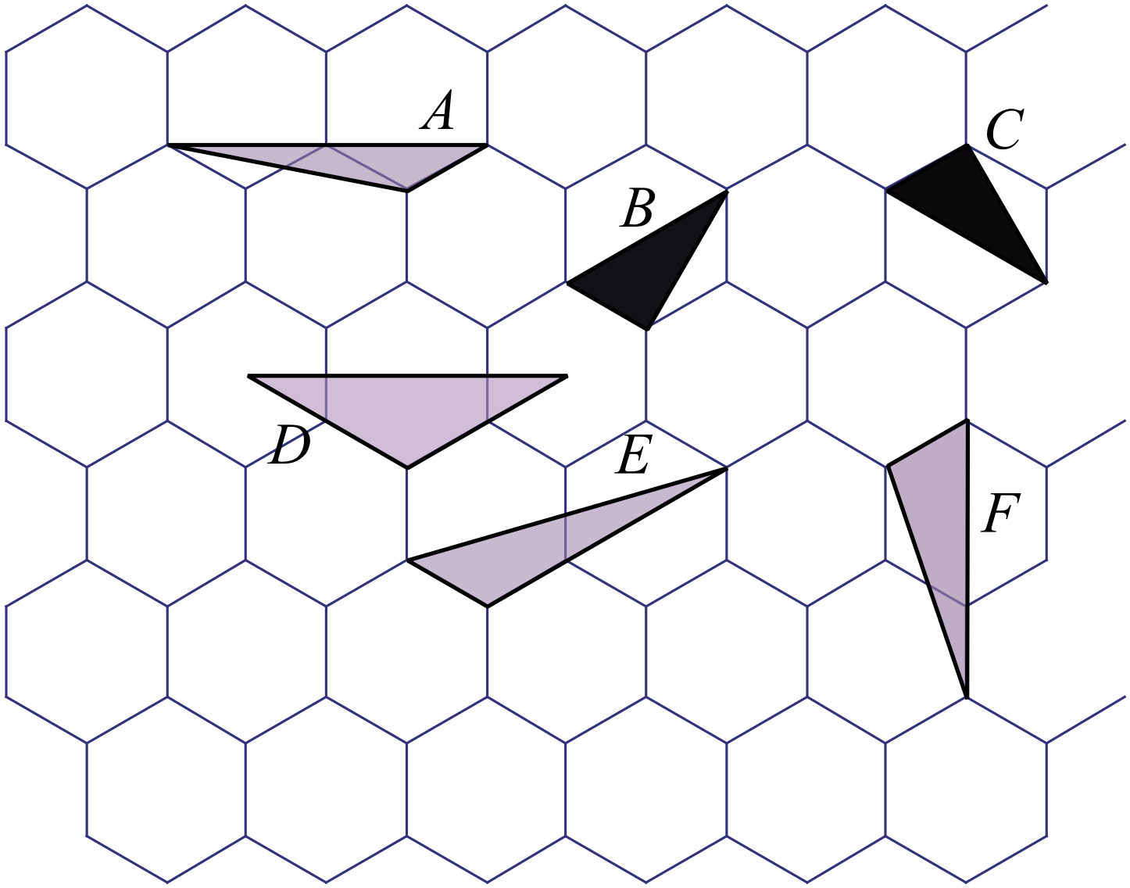

Triangles B and C are congruent and any of the tests except RHS could be used to prove congruence.

 | 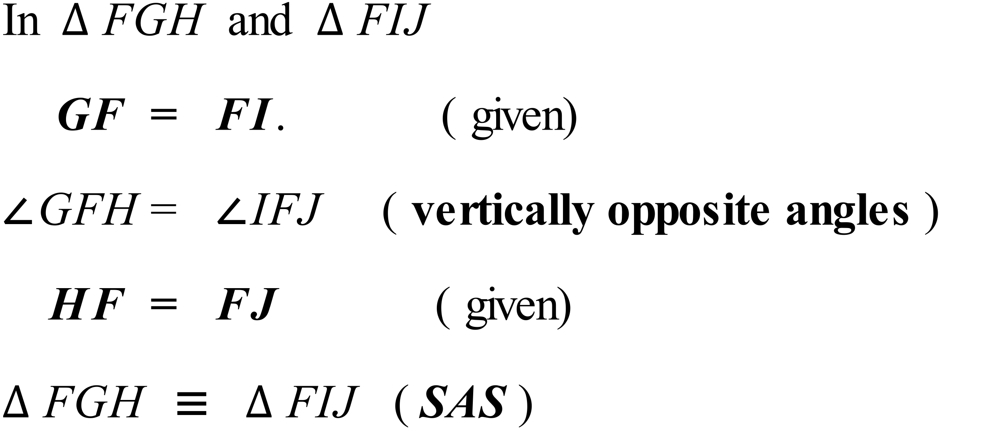
 | 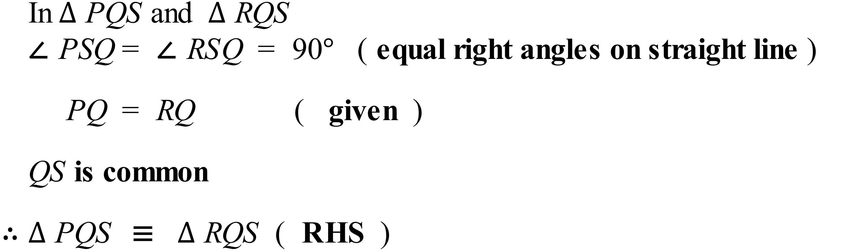

School Name
Mathematics Test 2017
Year 10 | Congruence | Calculator Allowed  Short Answer  Section

ANSWERS

Question |  | Answer
 | All of the smaller outer triangles are congruent, so there are 6 congruent triangles. | C
 | Rectangles U and W both measure 3 cm by 1.5 cm, so are congruent as all the angles are equal to 90º. | D
 | Triangle A has a pair of sides equal to those in triangle KLM and the angle included is equal. | A
 | A reflection in a vertical line would produce the image. | A
 | 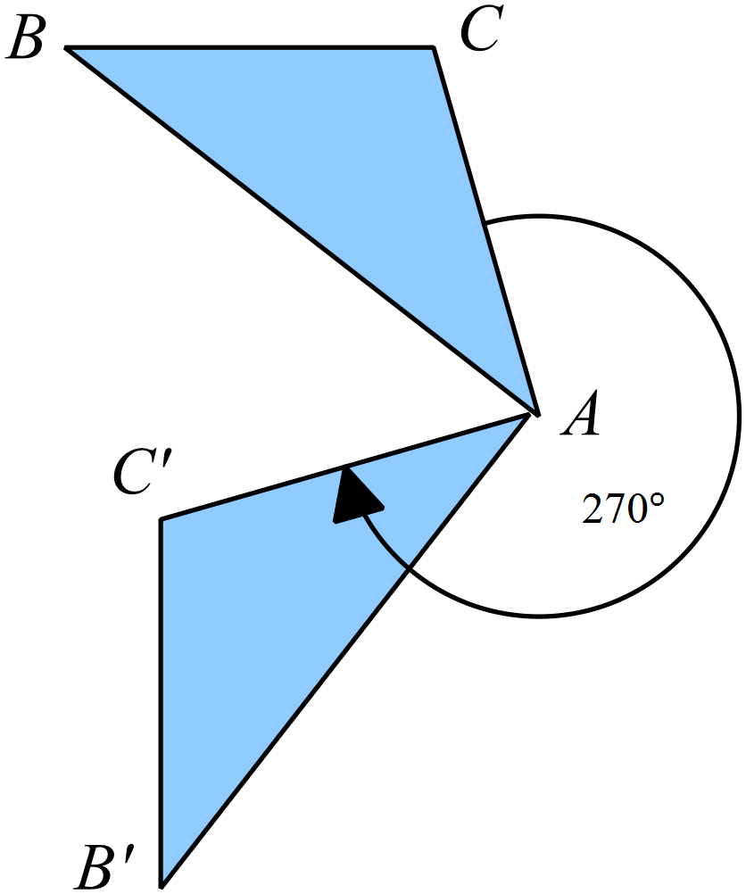 | D
 | Triangle C is congruent as RHS could be used. | C
 | 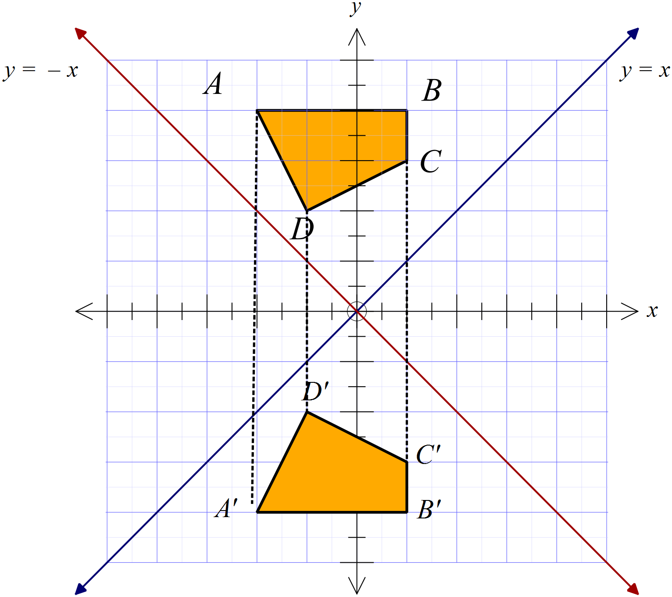A reflection in the x axis. | B
 | Shape A is a reflection of shape M. | A
 | as M rotates to Q and L rotates to S while O remains unchanged. | C
 | SAS using the right angle as the included angle.  AAS using the two given angles and the corresponding side. | B
 | 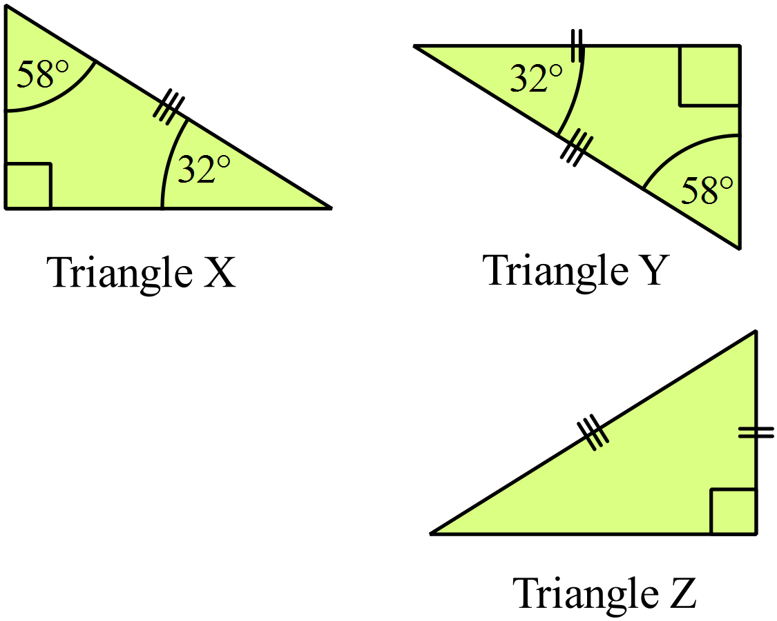  After finding the missing angles in X and Y, they are congruent by AAS, but Y and Z are congruent by RHS, so all three are congruent. | A
 | There are two pairs of congruent triangles, both with equal sides due to equal radii and included angles due to vertically opposite angles. These are and 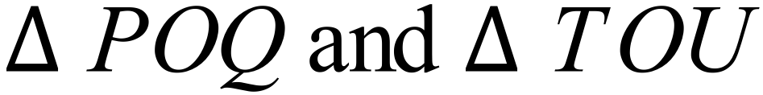  Of these only is listed. | D
 | 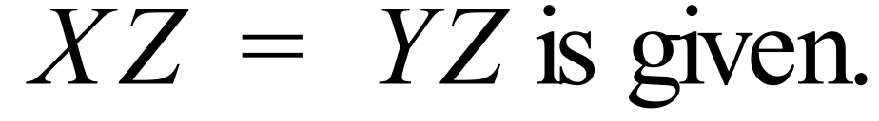  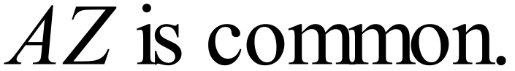  So there are three corresponding sides equal. SSS | D
 | So we need a pair of corresponding sides equal, is the only pair of the two listed which are in corresponding positions relative to the angles. | C
 | To achieve SAS, we need a side which is the other arm of the given angle. ST being common gives this. | B

School Name
Mathematics 2017
Multiple Choice Answer Sheet
Congruence
Name _____________________________________________
Completely fill the response oval representing the most correct answer.

1. A B C D
2. A B C D
3. A B C D
4. A B C D
5. A B C D
6. A B C D
7. A B C D
8. A B C D
9. A B C D
10. A B C D
11. A B C D
12. A B C D
13. A B C D
14. A B C D
15. A B C D

School Name
Mathematics Test 2017
Year 10 | Congruence | Calculator Allowed  Longer Answer  Section
ANSWERS
Question | Answer | Marks
1. | 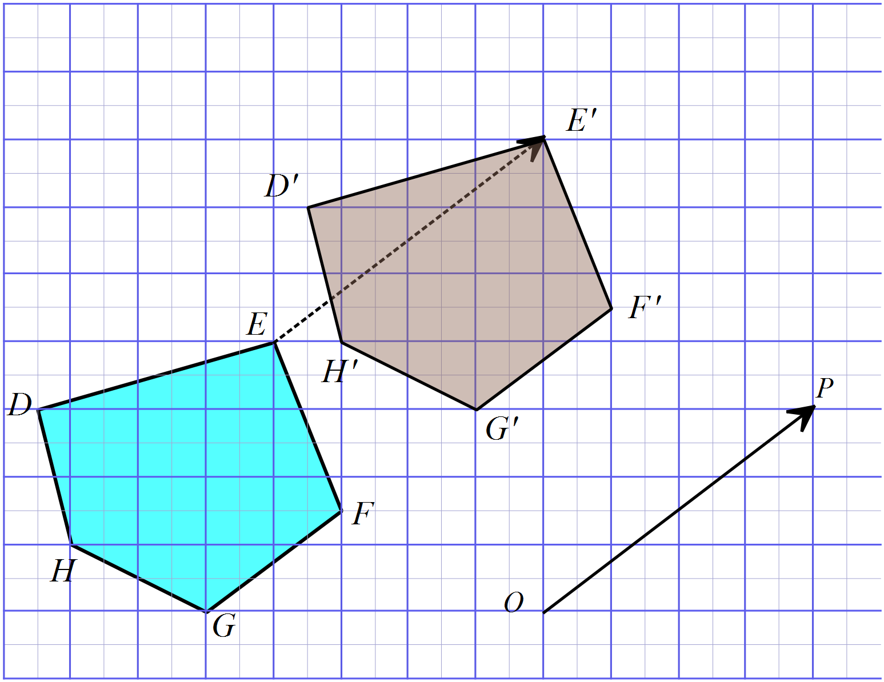(a) | 2 marks for accurate and correct image.  1 mark for an image which has a minor error in one or two vertices or is inaccurately drawn.
 | (b) Points in image are labelled as above. | 1 mark for correct labelling.
 | (c) They are equal in length and they are parallel. | 1 mark for each correct property.
2. | 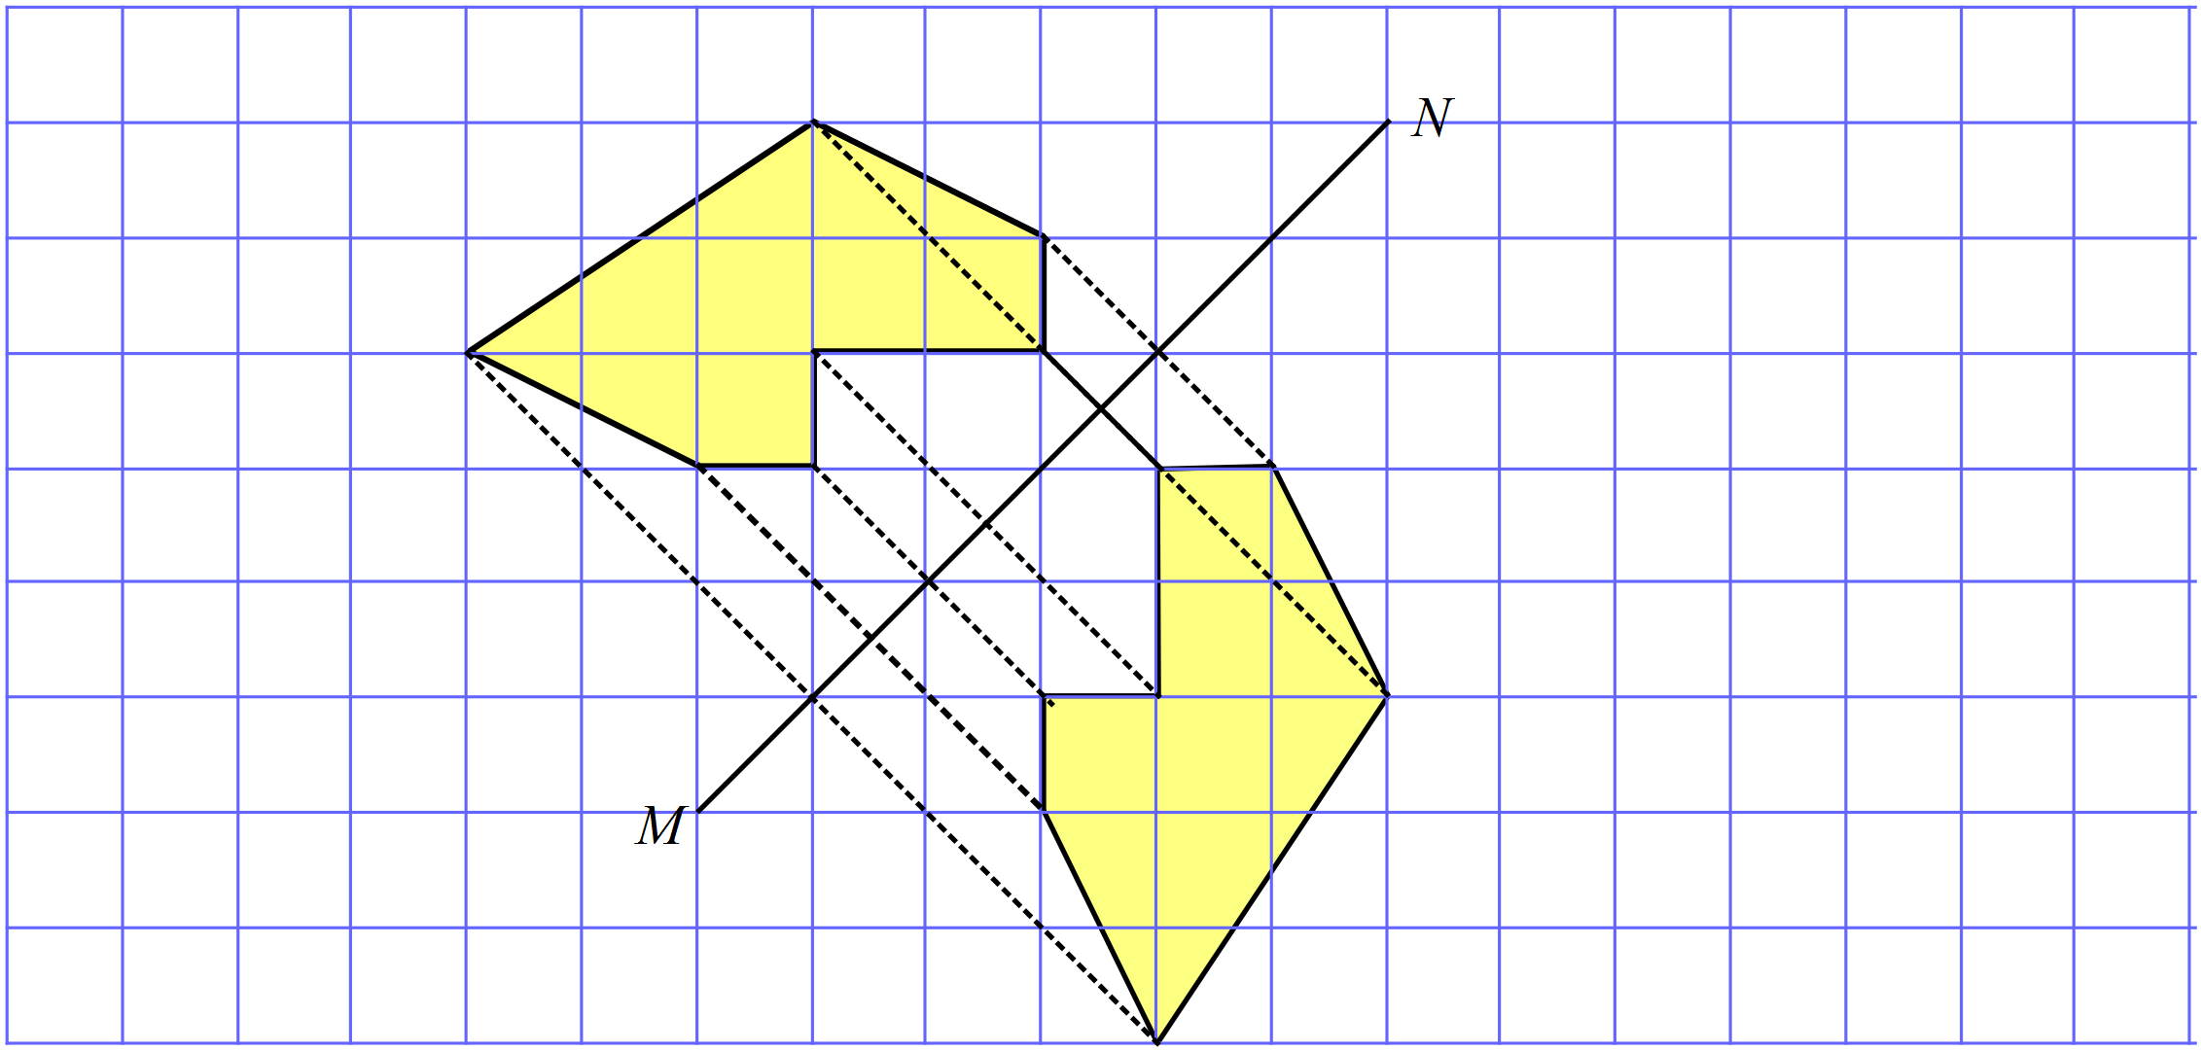(a) | 2 marks for accurate and correct image.  1 mark for an image which has a minor error in one or two vertices or is inaccurately drawn.
 | (b) They are the same. | 1 mark for correct answer
 | (c) They are the same. | 1 mark for correct answer
3. | 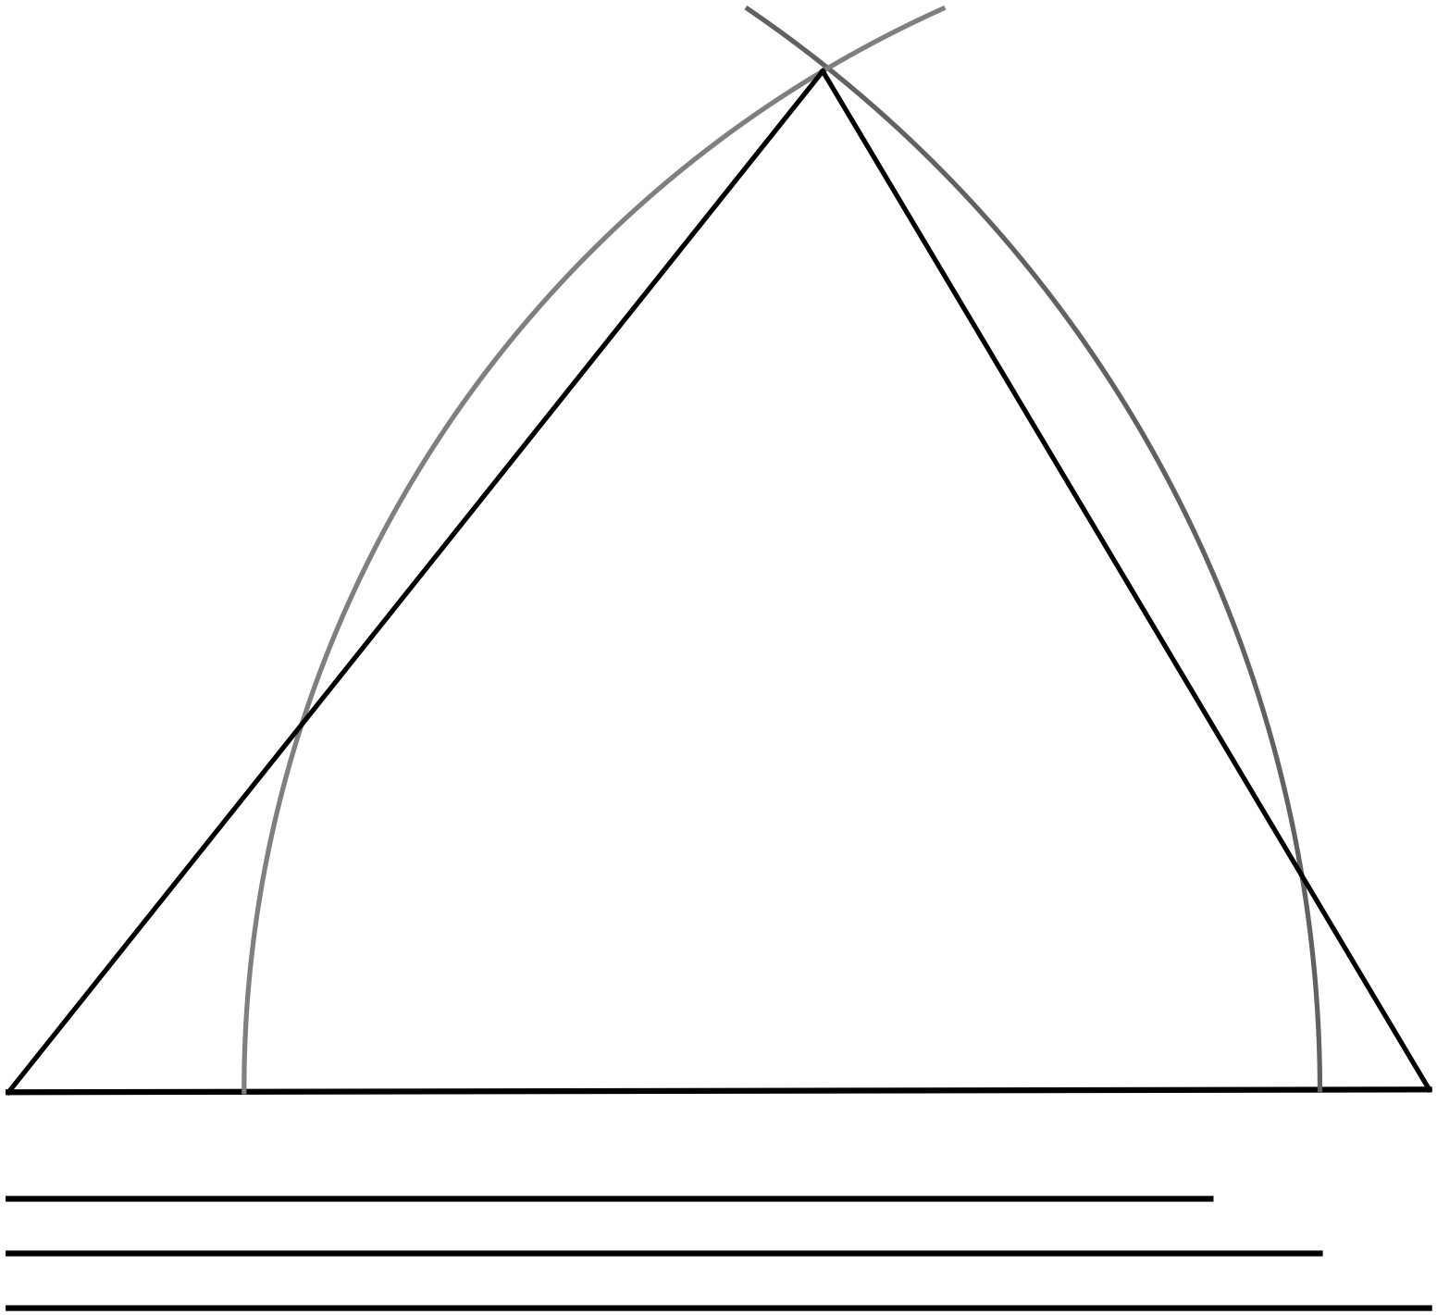(a) | 2 marks for correctly drawn triangle in any orientation showing construction lines.  1 mark for correctly drawn triangle in any orientation without construction lines.  1 mark for slightly inaccurately drawn triangle in any orientation showing construction lines.
 | 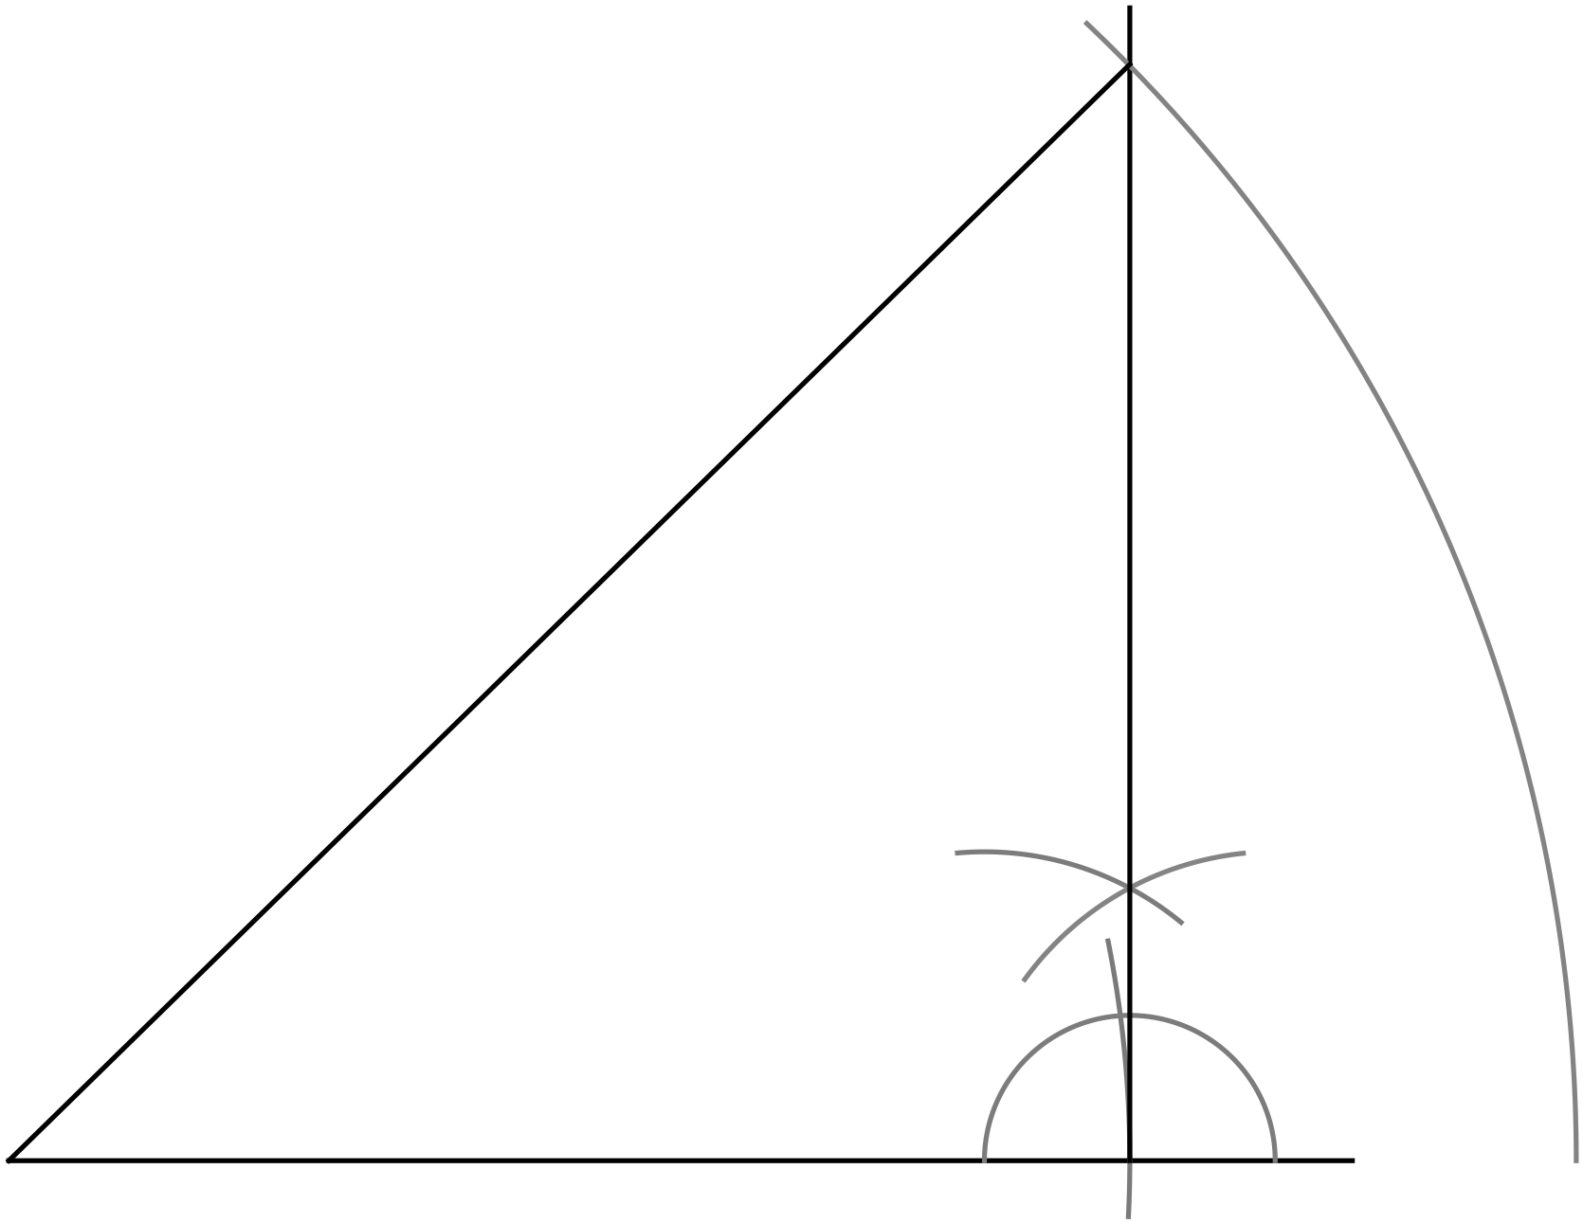(c) | 2 marks for correctly drawn triangle in any orientation showing construction lines.  1 mark for correctly drawn triangle in any orientation without construction lines.  1 mark for slightly inaccurately drawn triangle in any orientation showing construction lines.
4. | (a)  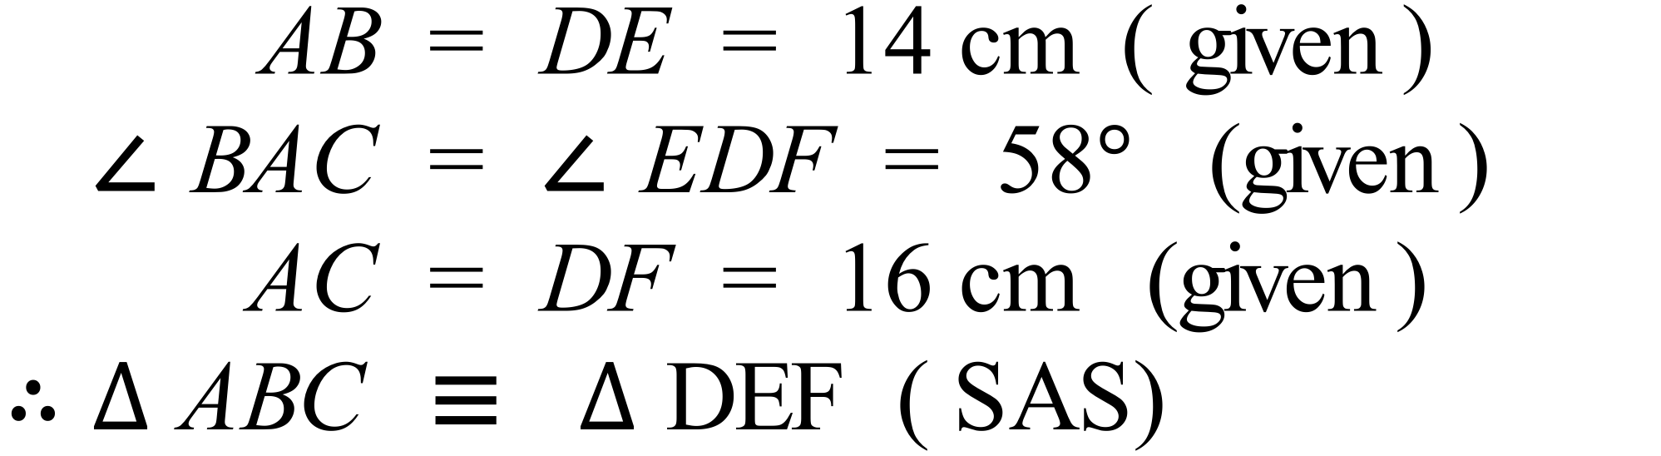 | 3 marks for complete proof with reasons  2 marks for complete proof except for a minor error  1 mark for partially correct proof (with incorrect reasons or lacking reasons)
 | (b)  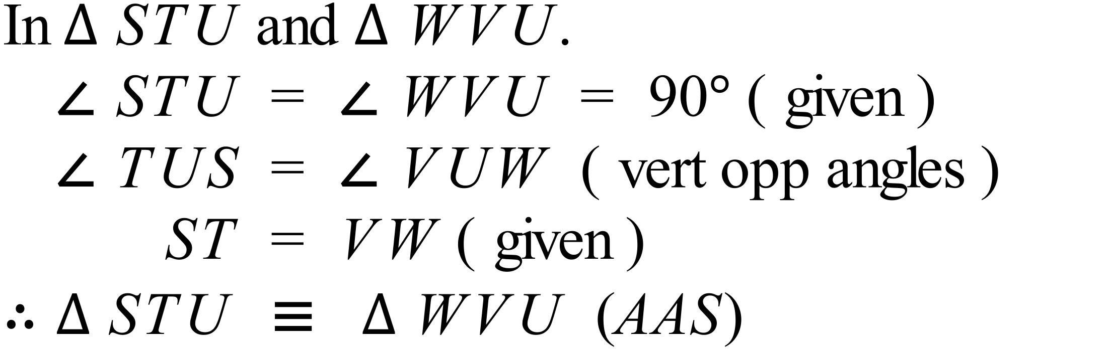  Alternative: TU = UV (U bisects TV) - therefore SAS as another proof | 3 marks for complete proof with reasons  2 marks for complete proof except for a minor error  1 mark for partially correct proof (with incorrect reasons or lacking reasons)
 | (c)  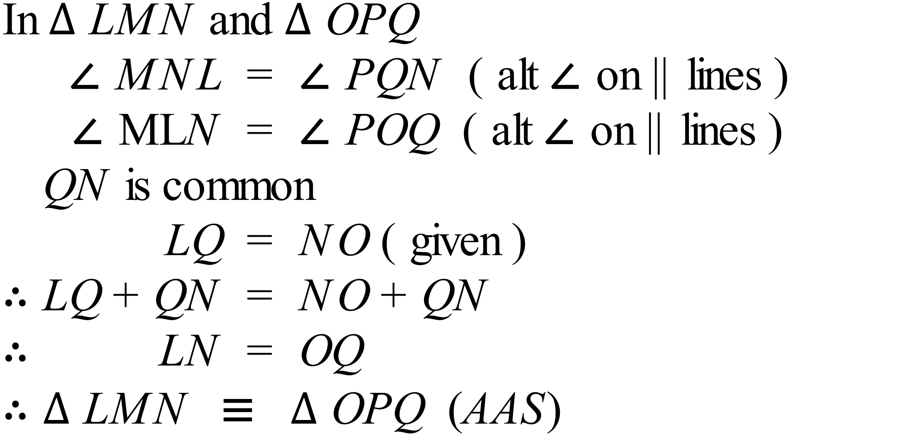 | 3 marks for complete proof with reasons  2 marks for complete proof except for a minor error  1 mark for partially correct proof (with incorrect reasons or lacking reasons)

